DAVID BOERNER
ECONOMICS 2302
“SKELETON” CLASS NOTES

SECTION I

ECONOMICS: STUDY OF HOW A SOCIETY USES ITS
LIMITED RESOURCES TO MAXIMIZE THE
UNLIMITED WANTS OF ITS MEMBERS

EVERY SOCIETY MUST ANSWER FOUR KEY QUESTIONS WITH ITS ECONOMIC SYSTEM:

- WHAT TO PRODUCE
- HOW MUCH TO PRODUCE
- FOR WHOM TO PRODUCE
- HOW TO PRODUCE IT

ECONOMIC RESOURCES OF A SOCIETY:

- LAND- ALL NATURAL RESOURCES
- LABOR- PHYSICAL AND MENTAL TALENTS USE IN THE ACTUAL PRODUCTION PROCESS
- CAPITAL- ALL MANUFACTURED AIDS USED IN THE PRODUCTION PROCESS
- ENTREPRENEURIAL ABILITY-
  - COMBINES THE OTHER RESOURCES IN THE PRODUCTION PROCESS
  - MAKES THE KEY BUSINESS DECISIONS
  - INNOVATOR
  - RISK TAKER

MACROECONOMICS - STUDY OF THE ECONOMY AS A WHOLE AND THE BASIC SUBDIVISIONS (HOUSEHOLDS, BUSINESS, AND GOVERNMENT)

MICROECONOMICS - THE STUDY OF INDIVIDUAL HOUSEHOLDS, BUSINESS ENTITIES, AND INDUSTRIES.

PRINCIPLES OF CAPITALISM

- PRIVATE PROPERTY- PROVIDES PERSONAL INCENTIVE

- ECONOMIC MAN- INDIVIDUAL, BY REACTING TO THEIR OWN BEST INTEREST, WILL BENEFIT SOCIETY AS WHOLE.

- FREE MARKETS- INDIVIDUAL CAN MOVE FREELY FROM ONE MARKET TO ANOTHER SUPPLYING RESOURCES AND PURCHASING GOODS.

- COMPETITION- LARGE NUMBER OF BUYERS AND SELLERS, SO LARGE THAT NO INDIVIDUAL OR GROUP CAN CONTROL THE MARKET.

- USE OF “THE PRICE SYSTEM”- THE PRICE OF A GOOD WILL ALLOCATE RESOURCES TO ITS PRODUCTION THRU THE INTRODUCTION OF SUPPLY AND DEMAND.

- LAISSEZ FAIRE- GOVERNMENT MUST FOLLOW A POLICY OF NON INTERFERENCE IN THE MARKET PLACE.

OTHER IMPORTANT TERMS:

MARGINAL ANALYSIS- ANALYSIS BASED ON THE EFFECTS OF THE NEXT INCREMENT OF THE VARIABLE IN QUESTION

OPPORTUNITY COST- THE GREATEST VALUED ALTERNATIVE GIVEN UP WHEN A SELECTION IS MADE BETWEEN ALTERNATIVES. (NO DECISION IS COST FREE.)

LAW: - A THEORY OR AN ABSTRACTION (GENERALIZATION) OF OBSERVED FACTS – “A SIMPLIFICATION OF REALITY”. WE WILL APPLY THE TERM “LAW” TO VARIOUS ECONOMIC IDEAS.

DISCUSSION OF ECONOMIC LAWS

CHARACTERISTICS OF ECONOMIC LAWS
- FOCUS ON KEY VARIABLES, WHILE TRYING TO ELIMINATE IRRELEVANT VARIABLES.
- “CETERIS PARIBUS” – ASSUME ALL OTHER VARIABLES EXCEPT THOSE UNDER CONSIDERATION ARE HELD CONSTANT (DO NOT CHANGE).
DANGERS IN CONSTRUCTING/APPLYING ANY THEORY
- EXCLUDE RELEVANT VARIABLES
- INCLUDE IRRELEVANT VARIABLE
- ASSUMING CORRELATION IMPLIES CAUSATION
- FALLACY OF COMPOSITION – WHAT IS TRUE OF A PART MAY NOT BE TRUE OF THE WHOLE

WHILE THE ABOVE ARE POSSIBLE ISSUES, WHEN WE APPLY THE TERM “LAW” TO OUR THEORIES IN ECONOMICS, WE ARE SAYING THAT THESE ISSUES DO NOT APPLY IN THESE CASES.

WHAT GRAPHS CAN SHOW US

GRAPHS ARE VISUAL REPRESENTATIONS OF THE RELATIONSHIP BETWEEN TWO VARIABLES.

GRAPHS PRESENT FOR US THE EFFECT THAT CHANGING ONE VARIABLE HAS ON THE OTHER.

WE CAN IDENTIFY TWO TYPE OF RELATIONSHIPS BETWEEN VARIABLES
- DIRECT RELATIONSHIPS: VARIABLES MOVE IN THE SAME DIRECTION. INCREASE IN ONE VARIABLE RESULTS IN AN INCREASE IN THE OTHER. DECREASE IN ONE VARIABLE –> DECREASE IN THE OTHER). GRAPH IS UPWARD SLOPING TO THE RIGHT.

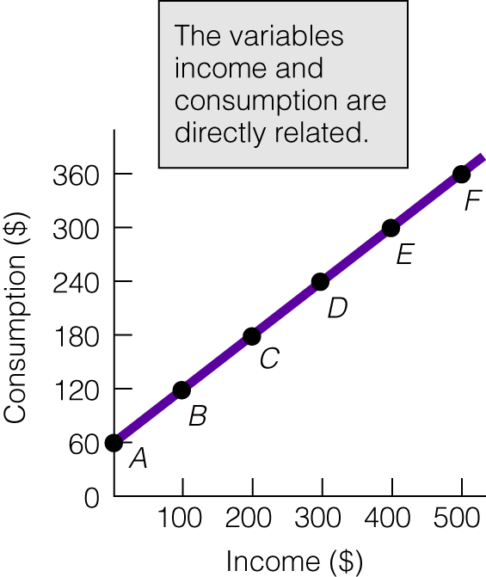

- INVERSE RELATIONSHIPS: VARIABLES MOVE IN OPPOSITE DIRECTIONS. INCREASE IN ONE VARIABLE RESULTS IN A DECREASE IN THE OTHER. INCREASE IN ONE VARIABLE –> DECREASE IN THE OTHER). GRAPH IS DOWNWARD SLOPING TO THE RIGHT.

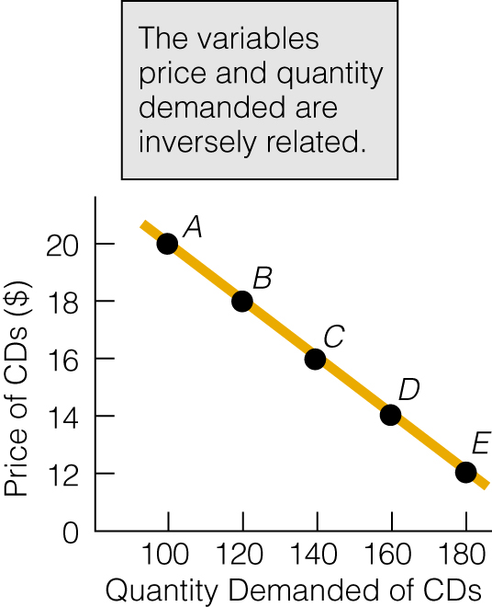

IF ONE OF THE VARIABLES HELD CONSTANT IS CHANGED, THEN THE RELATIONSHIP BETWEEN THE TWO VARIABLE ON THE GRAPH WILL CHANGE. THE CURVE ON THE GRAPH WILL SHIFT (SECOND CURVE ON THE GRAPH).

PRODUCTION POSSIBILITIES CURVE

THE PRODUCTION POSSIBILITIES CURVE IS A THEORETICAL TOOL USED TO INVESTIGATE THE EFFECTS OF OPPORTUNITY COST ON SOCIETY, HOW SOCIETY CHOOSES TO ALLOCATE ITS RESOURCES, AND FACTORS WHICH AFFECT A SOCIETY’S POTENTIAL LEVELS OF PRODUCTION.

IT IS DEVELOPED BASED ON THE FOLLOWING ASSUMPTIONS:
- FIXED QUANTITY ON RESOURCES
- THESE RESOURCES ARE PUT TO THEIR MOST EFFICIENT USE
- THERE IS A FIXED LEVEL OF TECHNOLOGY

THE CURVE IS A GRAPH IDENTIFYING ALL POSSIBLE COMBINATIONS OF TWO GOODS WHICH A SOCIETY IS CAPABLE OF PRODUCING.

EACH OUTPUT MUST MEET THE ABOVE ASSUMPTIONS.

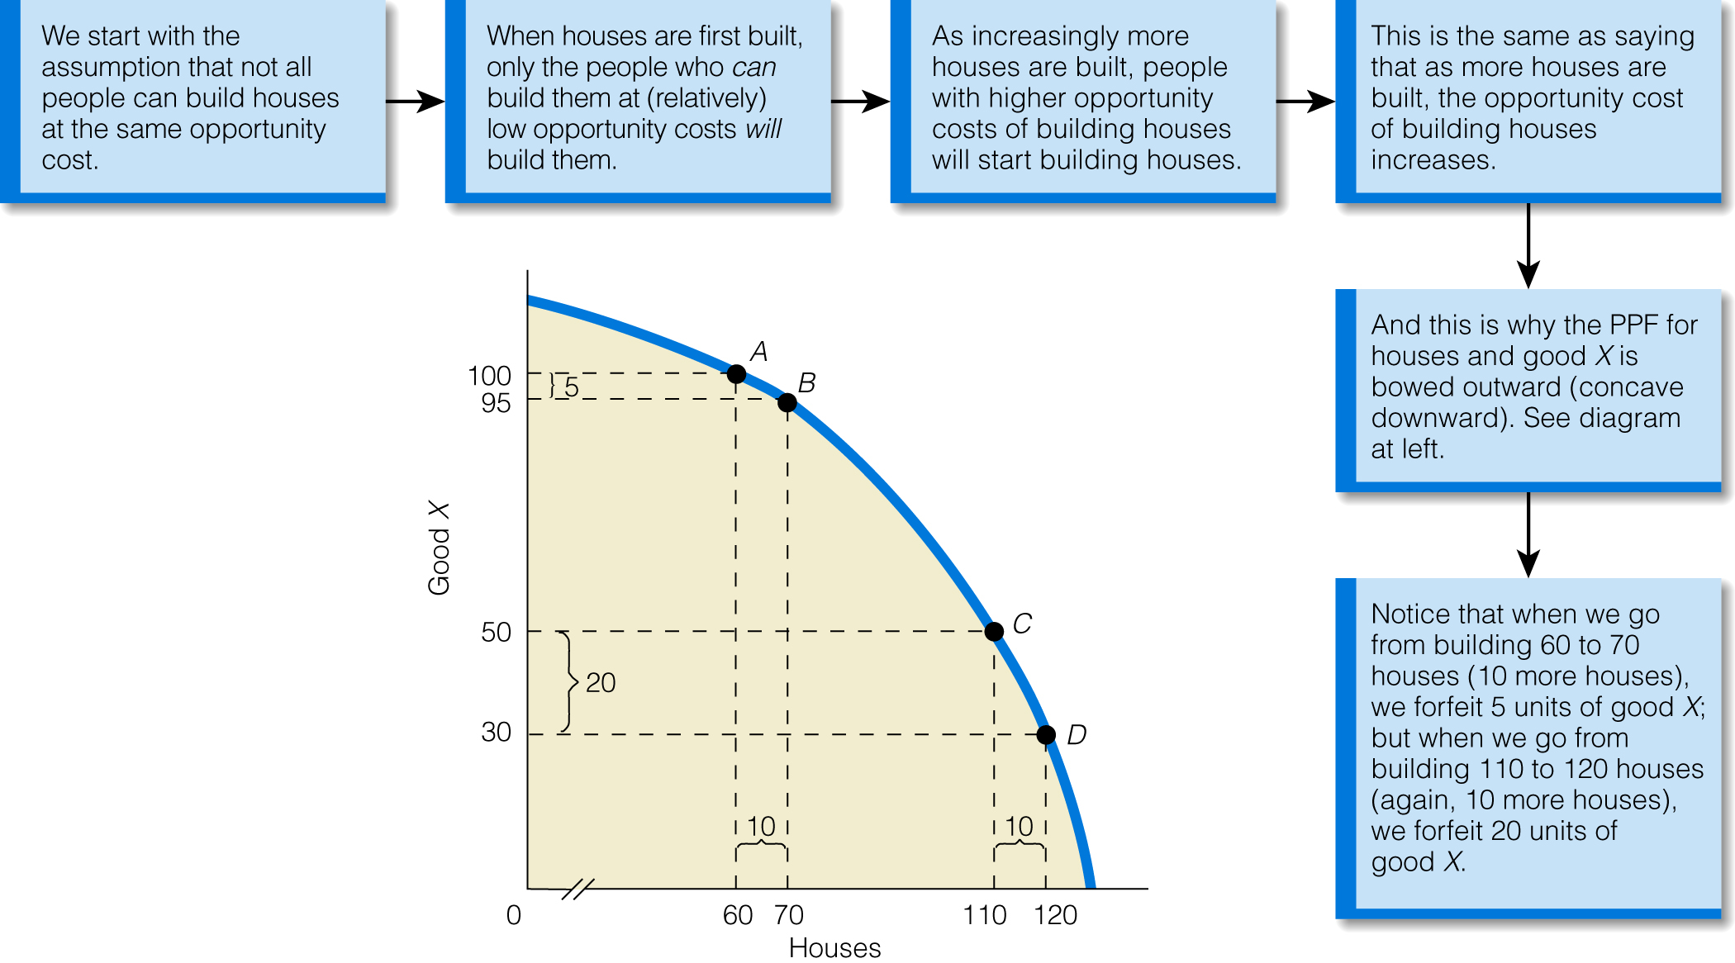

THE SHAPE OF THE PRODUCTION POSSIBILITY CURVE DERIVES FROM THE IDEA THAT INCREASED PRODUCTION OF EITHER GOOD CAN BE ACHIEVED ONLY AT THE EXPENSE OF GIVING UP UNITS OF THE OTHER GOOD.

TO INCREASE THE AMOUNT OF EITHER GOOD, SOCIETY MUST DIVERT RESOURCES FROM THE MOST SUITABLE USE TO ONE LESS SUITABLE. (THE COST OF PRODUCING AN ADDITIONAL UNIT OF ONE TYPE OF GOOD CAN ONLY BE ACHIEVED AT THE COST OF AN EVER LARGER DECREASE IN THE PRODUCTION OF THE OTHER GOOD. – LAW OF INCREASING RELATIVE COST) THERE IS A HIGHER OPPORTUNITY COST FOR EACH NEW UNIT OF EITHER GOOD PRODUCED.

OVER TIME THE PRODUCTIVE CAPACITY OF SOCIETY CAN BE INCREASE (SHIFTING OF THE CURVE OUTWARD) CAN BE ACHIEVED IF ANY OF THE FOLLOWING TAKES PLACE:
- IMPROVEMENT IN TECHNOLOGY (MORE PRODUCTION THE SAME RESOURCE)
- INCREASE IN SOCIETY’S RESOURCE BASE (INCREASE PRESENT PRODUCTION OF CAPITAL GOODS)
- INCREASE EFFICIENCY OF THE ECONOMY (LEGAL AND REGULATORY REFORM)

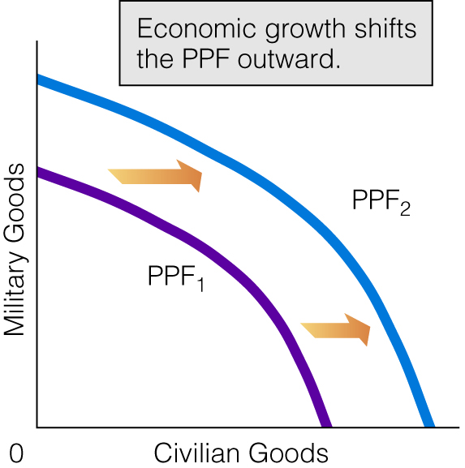

A POSITION OUTSIDE THE PRODUCTION POSSIBILITY CURVE IS NOT POSSIBLE. A POSITION INSIDE THE PRODUCTION POSSIBILITY CURVE IMPLIES AN INEFFICIENT USE OF RESOURCES.

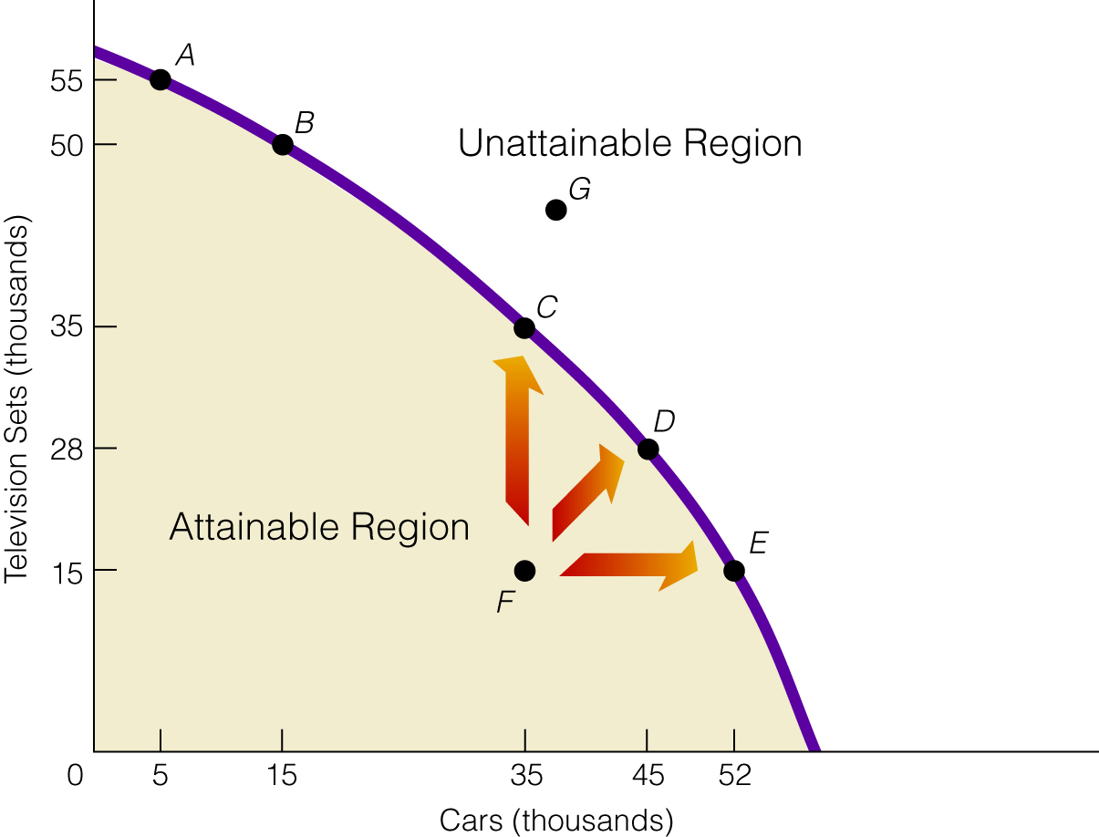

CHARACTERISTICS OF A PERFECTLY COMPETITIVE MARKET

- LARGE NUMBER OF BUYERS AND SELLERS
- NO GROUP OR INDIVIDUAL CONTROLS THE MARKET
- ALL INDIVIDUALS HAVE PERFECT KNOWLEDGE OF MARKET ALTERNATIVES

DEMAND: THE VARIOUS AMOUNTS OF A GOOD THAT BUYERS ARE BOTH WILLING AND ABLE TO BUY AT ALL POSSIBLE PRICES DURING A GIVEN PERIOD OF TIME, ALL OTHER THINGS REMAINING CONSTANT.

DETERMINANTS OF DEMAND

- PRICE OF THE GOOD
- CONSUMER’S TASTES AND PREFERENCES
- NUMBER OF CONSUMERS
- CONSUMERS INCOME
- PRICE OF RELATED GOODS
- RANGE OF GOODS AND SERVICES
- CONSUMERS EXPECTATIONS

LAW OF DEMAND: THERE IS AN INVERSE RELATIONSHIP BETWEEN THE PRICE OF A GOOD AND THE QUANTITY DEMANDED.

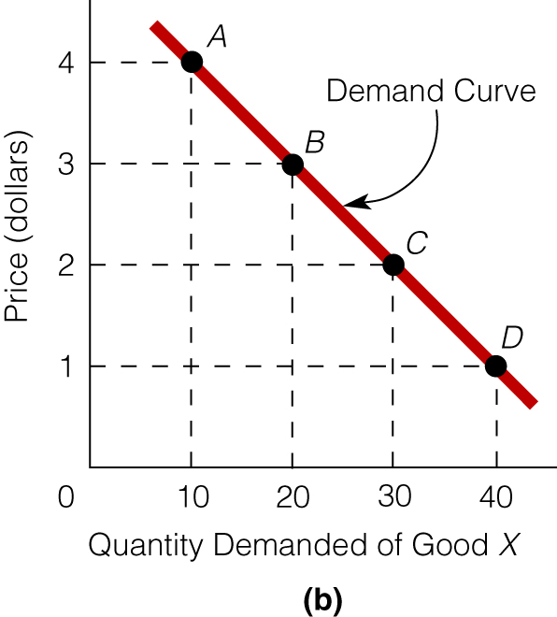

CHANGE IN PRICE RESULTS IN A CHANGE IN QUANTITY DEMANDED. ILLUSTRATED BY MOVEMENT ALONG ONE DEMAND CURVE.

IF THERE IS A CHANGE IN ONE OF THE OTHER DETERMINANTS OF DEMAND, THEN THERE IS A CHANGE IN DEMAND. ILLUSTRATED BY A SHIFT TO A NEW DEMAND CURVE.

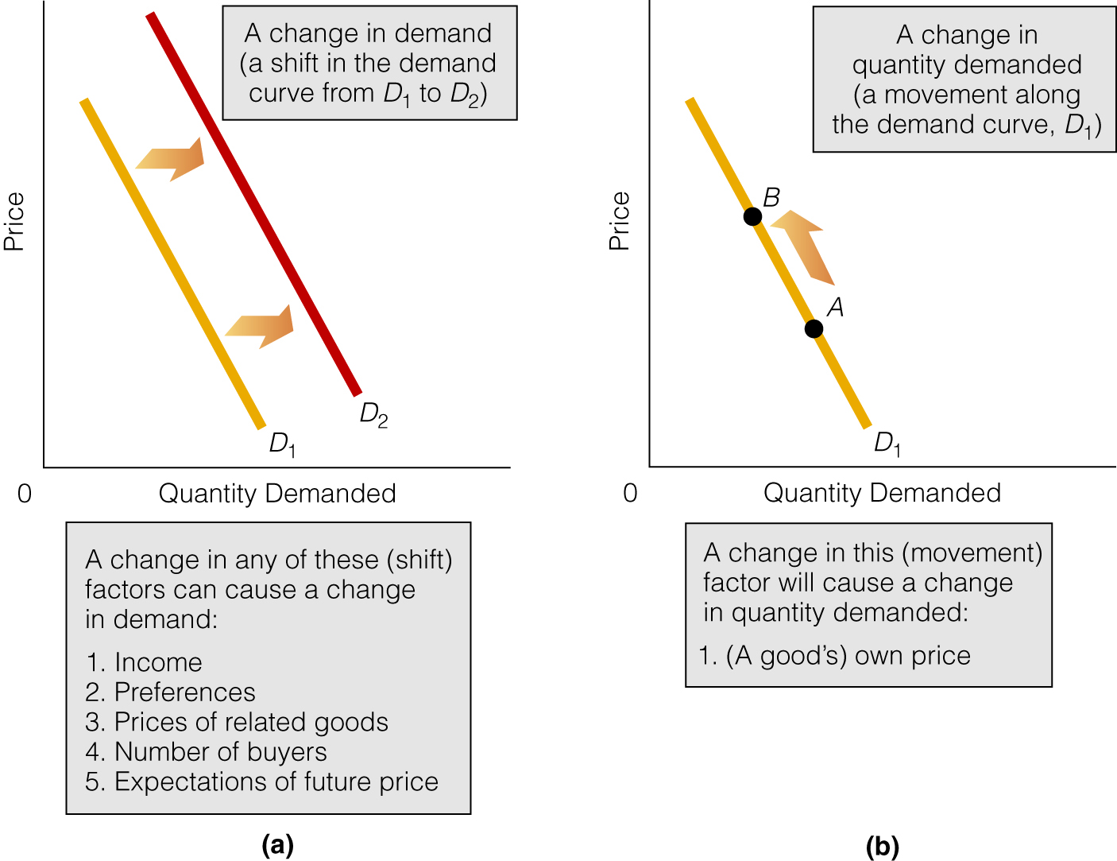

INCREASE IN DEMAND: SHIFT OF THE CURVE TO THE RIGHT

DECREASE IN DEMAND: SHIFT OF THE CURVE TO THE LEFT

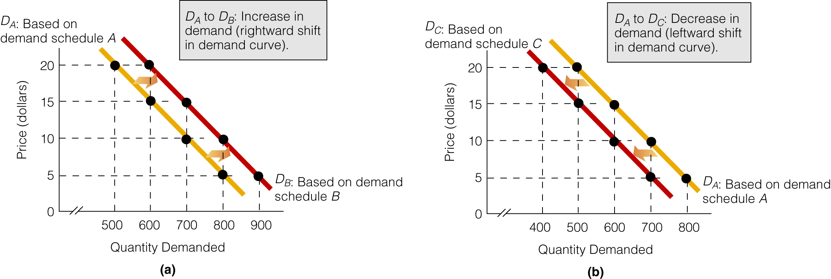

HOW NON PRICE DETERMINANTS AFFECT DEMAND

NUMBER OF CONSUMERS HAS A DIRECT EFFECT ON DEMAND

INCOME —(THERE ARE TWO TYPES OF GOODS TO ANALYZE)

NORMAL GOODS: DEMAND VARIES DIRECTLY WITH INCOME

INFERIOR GOODS: DEMAND VARIES INVERSELY WITH INCOME

RELATED GOODS—(TWO TYPES OF GOODS TO ANALYZE)

SUBSTITUTE GOODS: (GOODS USED IN PLACE OF EACH OTHER)
DEMAND FOR A GOOD VARIES DIRECTLY WITH THE PRICE OF IT SUBSTITUTE

COMPLEMENTARY GOODS: (GOODS USED TOGETHER)
DEMAND FOR A GOOD VARIES INVERSELY WITH PRICE OF ITS COMPLEMENT

SUPPLY: THE AMOUNT OF A GOOD THAT PRODUCERS ARE BOTH WILLING AND ABLE TO PRODUCE AND OFFER FOR SALE AT VARIOUS PRICES, DURING A GIVEN PERIOD OF TIME, ALL OTHER THINGS REMAINING CONSTANT.

LAW OF SUPPLY: THERE IS A DIRECT RELATIONSHIP BETWEEN THE PRICE OF A GOOD AND THE QUANTITY SUPPLIED

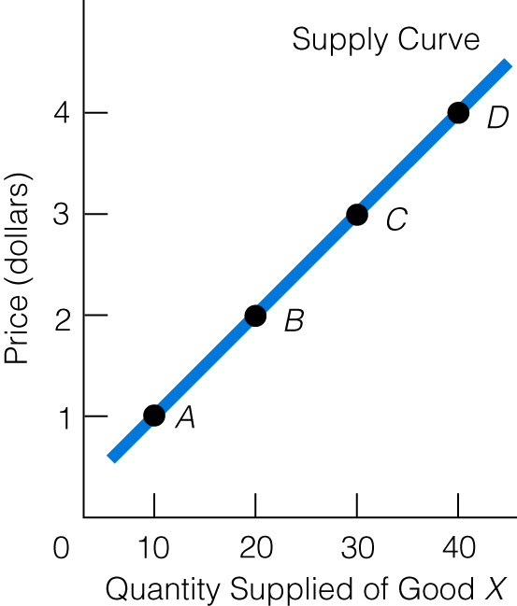

DETERMINANTS OF SUPPLY

- PRICE OF THE GOOD
- NUMBER OF SELLERS
- PRICE OF RESOURCES
- LEVEL OF TECHNOLOGY
- PRICE OF OTHER PRODUCTS WHICH CAN BE PRODUCED WITH THE SAME RESOURCES
- EXPECTATION OF PRODUCERS
- SUBSIDIES AND TAXES

CHANGE IN QUANTITY SUPPLIED- RESULTS FROM CHANGE IN PRICE. (MOVEMENT ALONG THE SAME CURVE)

CHANGE IN SUPPLY- RESULTS FROM CHANGE IN ONE OF THE OTHER DETERMINANTS OF SUPPLY. (NEW CURVE.)

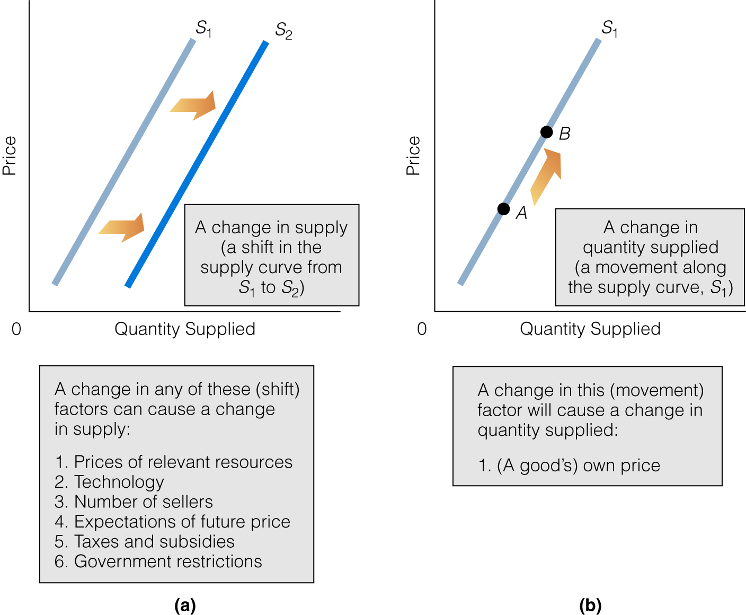

INCREASE IN SUPPLY- SHIFT OF THE CURVE TO THE RIGHT

DECREASE IN SUPPLY- SHIFT OF THE CURVE TO THE LEFT.

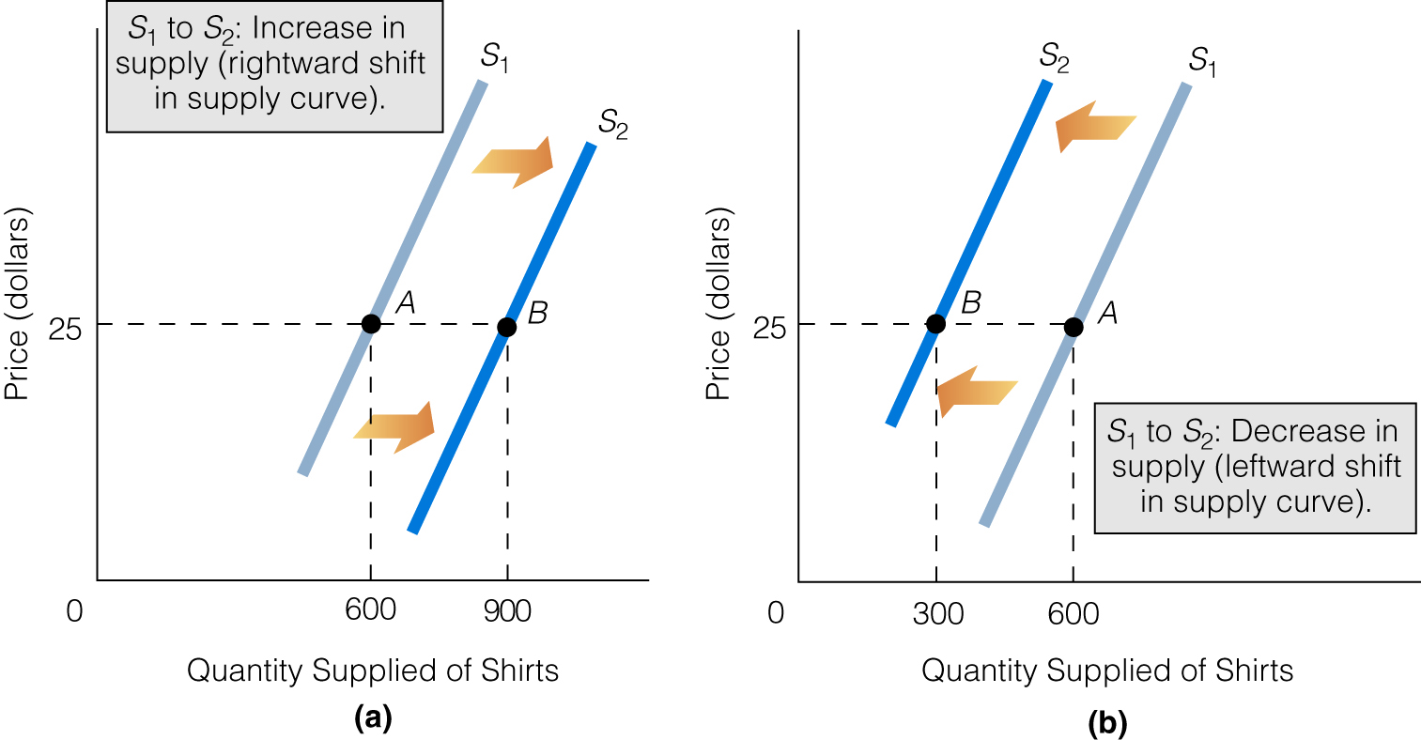

AFFECTS ON SUPPLY OF THE OTHER DETERMINANTS

NUMBER OF SUPPLIERS: DIRECT EFFECT ON SUPPLY

COST OF PRODUCTION: PRICE OF RESOURCES, TECHNOLOGY, SUBSIDIES & TAXES ALL AFFECT THE COST OF PRODUCTION. WE CAN MAKE A GENERALIZATION OF THEIR EFFECT ON SUPPLY:

INVERSE RELATIONSHIP BETWEEN THE COST OF PRODUCTION AND SUPPLY.

IMPROVEMENTS IN TECHNOLOGY - INCREASE SUPPLY
PRICE OF RESOURCES—INVERSE EFFECT ON SUPPLY
TAXES—INVERSE EFFECT ON SUPPLY

EQUILIBRIUM

EQUILIBRIUM POINT: THE POINT OF INTERSECTION BETWEEN THE DEMAND AND SUPPLY CURVES.

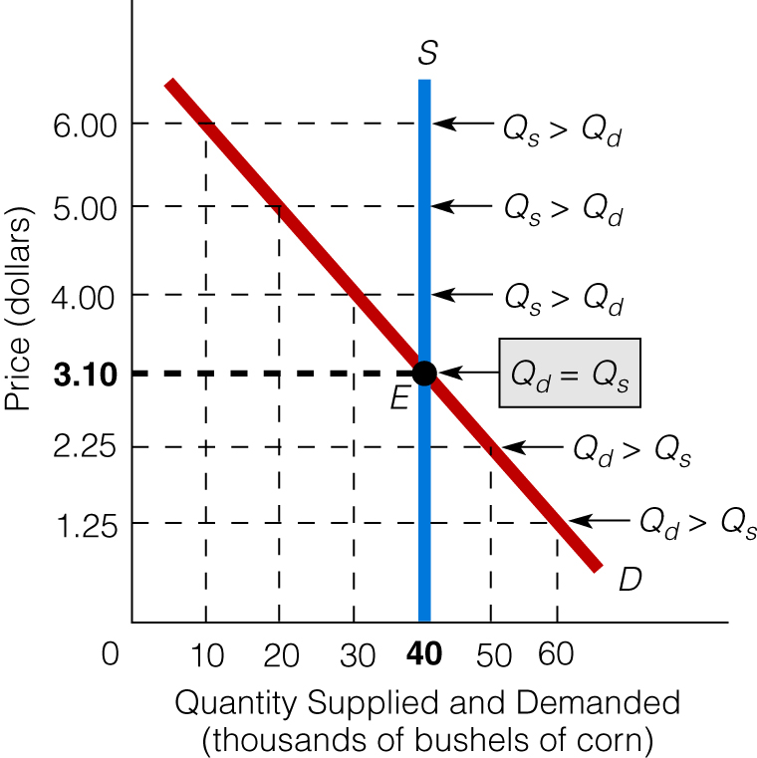

AT EQUILIBRIUM THERE IS AN EQUILIBRIUM PRICE AND EQUILIBRIUM QUANTITY. ALL SELLERS WILL BE ABLE TO SELL THE QUANTITY OF THE GOOD THEY DESIRE, AND ALL BUYERS WILL BE ABLE TO PURCHASE THE QUANTITY OF THE GOOD THEY DESIRE AT THE EQUILIBRIUM PRICE.

QUANTITY DEMANDED= QUANTITY SUPPLIED
(THE EQUILIBRIUM QUANTITY.)

A FURTHER IDEA OF EQUILIBRIUM:
DEMAND AND SUPPLY ARE “IN BALANCE” (EQUAL).
THERE IS NO INHERENT PRESSURE IN THE MARKET FOR CHANGE TO OCCUR. THE MARKET WILL STAY AT THIS POSITION OF EQUILIBRIUM UNTIL AN OUTSIDE FORCE RESULTS IN A CHANGE IN EITHER DEMAND OF SUPPLY.

FINAL IDEA:
IF AN OUTSIDE FORCE DOES RESULT IN A CHANGE TO EITHER DEMAND OF SUPPLY, AND THE MARKET IS ALLOWED TO REACT TO THE CHANGE, THEN THE MARKET WILL SETTLE AT A NEW EQUILIBRIUM POINT.

EFFECTS ON EQUILIBRIUM PRICE AND EQUILIBRIUM QUANTITY RESULTING FORM CHANGES IN DEMAND OR SUPPLY

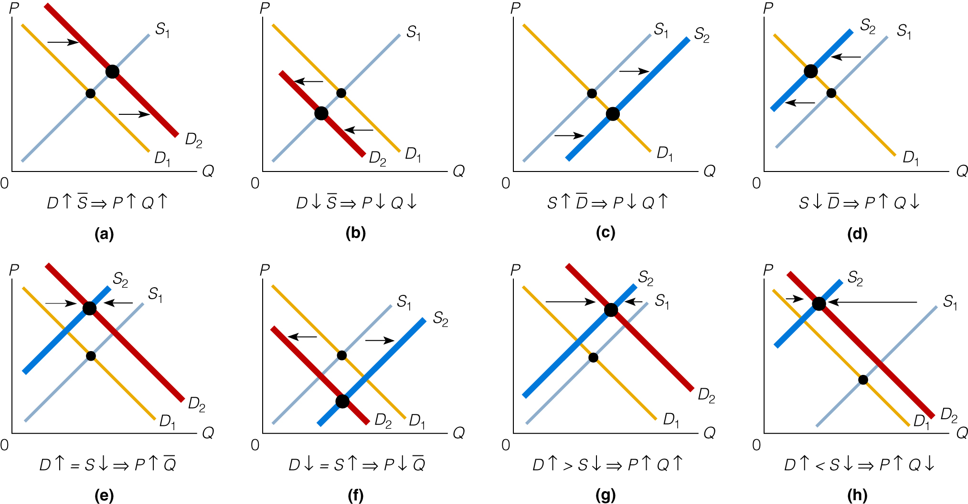

SHORTAGES & SURPLUSES

A PRICE SET BELOW THE EQUILIBRIUM PRICE WILL CREATE A SHORTAGE SITUATION (QUANTITY DEMANDED IS LARGER THAN QUANTITY SUPPLIED).

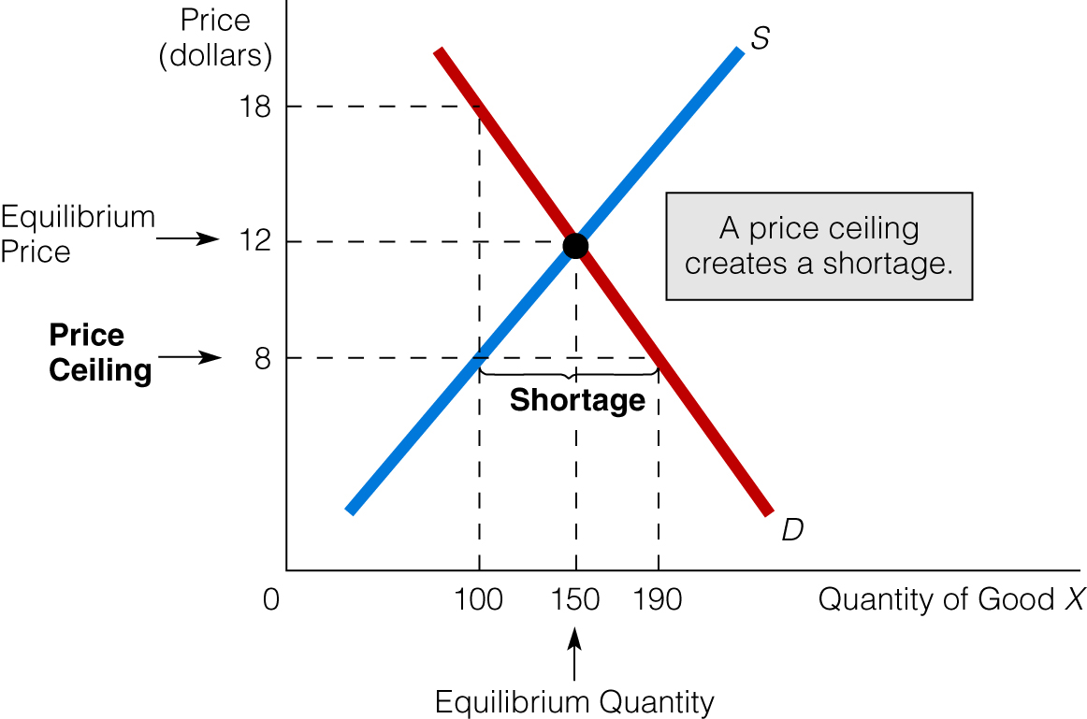

A PRICE SET ABOVE THE EQUILIBRIUM PRICE WILL CREATE A SURPLUS SITUATION (QUANTITY SUPPLIED IS LARGER THAN QUANTITY DEMANDED).

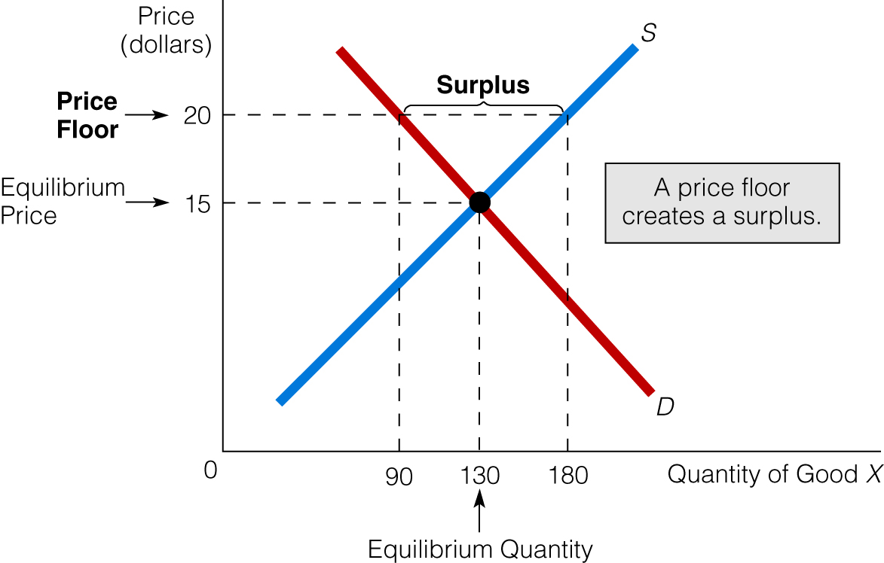

ONLY “GOVERNMENT” CAN MANDATE PRICING RESULTING IN A SHORTAGE OR SURPLUS SITUATION.

HOW THE PRICE SYSTEM ALLOCATES RESOURCES

DEFINITIONS

NORMAL PROFIT: THE HIGHEST RETURN THAT OWNERS OF RESOURCES COULD EXPECT TO RECEIVE IN ANY OTHER ENDEAVOR. (OPPORTUNITY COST.) THIS IDEA ALSO APPLIES TO THE OWNER OF ENT. ABILITY.

IMPORTANCE: FOR THE EMPLOYMENT OF RESOURCES, THEIR OWNERS MUST BE PAID AT LEAST A NORMAL PROFIT.

ECONOMIC PROFIT: ANY RETURN TO THE BUSINESS OWNER (OWNER OF ANT. ABILITY) ABOVE A NORMAL PROFIT.

IN A CAPITALIST SYSTEM, RESOURCES ALLOCATED AS A RESULT OF CONSUMER SOVEREIGNTY. (MEANING: THE DEMANDS OF THE CONSUMER LEAD TO THE PRODUCTION OF GOODS.)

THE CHOICES OF CONSUMERS ARE TRANSMITTED TO BUSINESSES THROUGH ECONOMIC PROFITS & LOSSES.

ECONOMIC PROFITS WILL EXIST IN MARKETS FOR WHICH CONSUMERS DESIRE MORE GOODS PRODUCED.

HOW PROFITS ARE CREATED AND ALLOCATE RESOURCES

- MARKET IS INITIALLY IN A STATE OF EQUILIBRIUM. (PRICE IS EQUAL TO THE COST OF PRODUCTION—NORMAL PROFIT FOR THE FIRMS)

- SOMETHING RESULTS IN AN INCREASE IN DEMAND FOR THE PRODUCT. (PRICE INCREASES AND IS NOW HIGHER THAN THE COST OF PRODUCTION—ECONOMIC PROFIT FOR THE FIRMS.

- FIRMS IN THE INDUSTRY WILL INCREASE PRODUCTION (ALLOCATE ADDITIONAL RESOURCES), SINCE THERE IS FREEDOM TO ENTER AND EXIT MARKETS, FIRMS IN MARKETS EXPERIENCING ONLY A NORMAL PROFIT IN THEIR CURRENT MARKET, WILL SEE THE ECONOMIC PROFITS AVAILABLE IN THIS MARKET AND ENTER—RESULTING IN AND INCREASE IN SUPPLY

- WITH EACH NEW FIRM ENTERING THE MARKET, SUPPLY INCREASES, LEADING TO A DECLINE IN PRICE (AND AS A RESULT—DECLINE IN ECONOMIC PROFITS.)

- STAGE IV WILL CONTINUE AS LONG AS THERE ARE ECONOMIC PROFITS. (ECONOMIC PROFITS CONTINUE TO GET SMALLER.) MOVEMENT OF NEW FIRMS INTO THE MARKET WILL STOP WHEN THE FIRMS IN THE INDUSTRY AGAIN EARN ONLY A NORMAL PROFIT—THIS IS EQUILIBRIUM FOR THE INDIVIDUAL FIRMS AND THE MARKET.

BENEFIT FOR SOCIETY—INCREASE IN PRODUCTION (ALLOCATION OF ADDITIONAL RESOURCES) TO MATCH DESIRES OF CONSUMERS.

HOW ECONOMIC LOSSES ARE CREATED AND ALLOCATE RESOURCES

- MARKET IS INITIALLY IN A STATE OF EQUILIBRIUM. (PRICE IS EQUAL TO THE COST OF PRODUCTION—NORMAL PROFIT FOR THE FIRMS)

- SOME THING RESULTS IN A DECREASE IN DEMAND FOR THE PRODUCT. (PRICE DECREASES AND IS NOW LOWER THAN THE COST OF PRODUCTION—ECONOMIC LOSS FOR THE FIRMS.

- FIRMS IN THE INDUSTRY WILL DECREASE PRODUCTION (FREEING RESOURCES TO ALLOCATED ELSEWHERE), SINCE THERE IS FREEDOM TO ENTER AND EXIT MARKETS, SOME FIRMS WILL ELECT TO LEAVE THEIR CURRENT MARKET ENTIRELY—THIS WILL RESULT IN A DECREASE ON SUPPLY

- WITH EACH NEW FIRM LEAVING THE MARKET, SUPPLY DECREASES, LEADING TO AN INCREASE IN PRICE (AND AS A RESULT—REDUCTION IN ECONOMIC LOSSES).

- STAGE IV WILL CONTINUE AS LONG AS THERE ARE ECONOMIC LOSSES. (ECONOMIC LOSSES CONTINUE TO GET SMALLER.) MOVEMENT OF NEW FIRMS OUT OF THE MARKET WILL STOP WHEN THE FIRMS IN THE INDUSTRY AGAIN EARN AN NORMAL PROFIT—THIS IS EQUILIBRIUM FOR THE INDIVIDUAL FIRMS AND THE MARKET.

BENEFIT FOR SOCIETY—DECREASE IN PRODUCTION (RESOURCES ARE FREED UP TO BE REALLOCATED ELSEWHERE) TO MATCH DESIRES OF CONSUMERS.

THE DEMAND FOR RESOURCES IS A DERIVED DEMAND. THE DEMAND FOR RESOURCES IS DEPENDED ON THE DEMAND FOR THE GOODS THEY ARE USED TO PRODUCE.

ANALYSIS OF CONSUMER DECISIONS

THE DOWNWARD SLOPE OF THE DEMAND CURVE (THE INVERSE RELATIONSHIP BETWEEN PRICE AND QUANTITY DEMANDED) RESULTS FROM TWO EFFECTS CAUSED BY A CHANGE IN PRICE.

THE INCOME EFFECT- A CHANGE IN THE PRICE OF A GOOD WILL RESULT IN A CHANGE IN THE QUANTITY OF THE GOOD THAT CAN BE BOUGHT WITH THE SAME AMOUNT OF MONEY. (A CHANGE IN THE REAL INCOME OF THE CONSUMERS)

THE SUBSTITUTION EFFECT- AS THE PRICE OF A GOOD IS CHANGED, THE SATISFACTION PER DOLLAR OF COST OF OFFERS COMPARED TO OTHER GOODS WILL CHANGE. THE CONSUMER WILL SUBSTITUTE OR CHANGE HIS SELECTION BASED ON THIS RELATIVE VALUE.

TO UNDERSTAND THE SUBSTITUTION EFFECT, WE MUST LOOK AT MARGINAL UTILITY ANALYSIS

MARGINAL- NEXT UNIT
UTILITY- SATISFACTION RESULTING FROM THE CONSUMPTION OF UNIT OF GOOD

THE LAW OF DIMINISHING MARGINAL UTILITY- THE PRINCIPLE THAT AS ADDITIONAL UNITS OF A GOOD ARE CONSUMED, A POINT WILL BE REACHED WHERE EACH ADDITIONAL UNIT CONSUMED WILL PROVIDE LESS SATISFACTION THAN THE PRIOR UNIT CONSUMED.

TO EXAMINE CONSUMERS’ DECISIONS WE MUST MAKE TO ASSUMPTIONS:

CONSUMERS HAVE LIMITED BUDGETS
CONSUMERS ARE RATIONAL IN THEIR BEHAVIOR

APPLYING THESE TWO ASSUMPTIONS WE CAN CONCLUDE THAT CONSUMERS WILL OPERATE UNDER A RULE OF MAXIMIZING UTILITY.

THE RULE OF MAXIMIZING UTILITY : CONSUMERS WILL ALLOCATE THEIR INCOME BETWEEN THE CONSUMPTION OF GOODS SO THAT THE LAST DOLLAR SPENT ON EACH GOOD WILL YIELD THE SAME MARGINAL UTILITY. (THE CONSUMER WILL PURCHASE THE NEXT UNIT OF A GOOD WHICH WILL PROVIDE A HIGHER UTILITY PER DOLLAR OF COST.)

PRICE ELASTICITY OF DEMAND

PRICE ELASTICITY OF DEMAND MEASURE THE RESPONSIVENESS OF QUANTITY DEMANDED TO CHANGE IN THE PRICE OF THE GOOD.

PERCENTAGE CHANGE IN QUANTITY DEMANDED
___________________________________________

PERCENTAGE CHANGE IN PRICE

IF THE % CHANGE IN QUANTITY DEMANDED IS LARGER THAN THE % CHANGE IS PRICE (E>1), THEN DEMAND IS CONSIDERED RELATIVELY ELASTIC. THE LARGER THE VALUE OF E THE MORE PRICE ELASTIC DEMAND IS CONSIDERED TO BE.

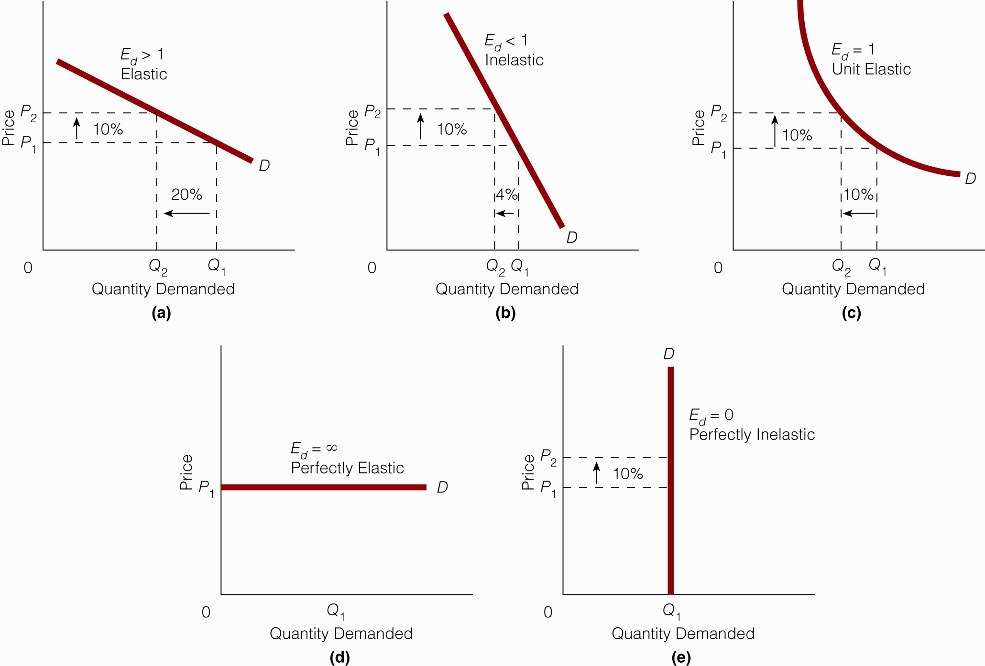

IF THE % CHANGE IN QUANTITY DEMANDED IS SMALLER THAN THE % CHANGE IN PRICE (0<E<1), THEN DEMAND IS CONSIDERED TO BE RELATIVELY INELASTIC. THE SMALLER THE VALUE OF E THE MORE INELASTIC DEMAND IS CONSIDERED TO BE.

PERFECT ELASTICITY IS THE SITUATION IN WHICH THERE IS UNLIMITED DEMAND AT THE MARKET PRICE, BUT DEMAND DISAPPEARS COMPLETELY IF PRICE WERE TO MOVE UP IN ANY WAY. DEMAND CURVE IS PERFECTLY ELASTIC.

PERFECT PRICE INELASTICITY IS THE SITUATION IN WHICH QUANTITY DEMANDED IS UNCHANGING AT ANY PRICE. DEMAND CURVE IS VERTICAL

WITH THE EXCEPTION OF THE ABOVE UNIQUE SITUATIONS:

THE PRICE ELASTICITY OF DEMAND CHANGES AS PRICE CHANGES ALONG A DEMAND CURVE. THIS DETERMINES THE EFFECT OF A PRICE CHANGE ON TOTAL REVENUE.

THE UPPER LEFT PORTION OF THE DEMAND CURVE (HIGHER PRICE LOWER QUANTITY) IS RELATIVELY ELASTIC (LARGER PERCENTAGE CHANGE IN QUANTITY THAN PRICE)

THE LOWER RIGHT PORTION OF THE DEMAND CURVE (LOWER PRICE, HIGHER QUANTITY) IS RELATIVELY INELASTIC (SMALLER PERCENTAGE CHANGE IN QUANTITY THAN PRICE)

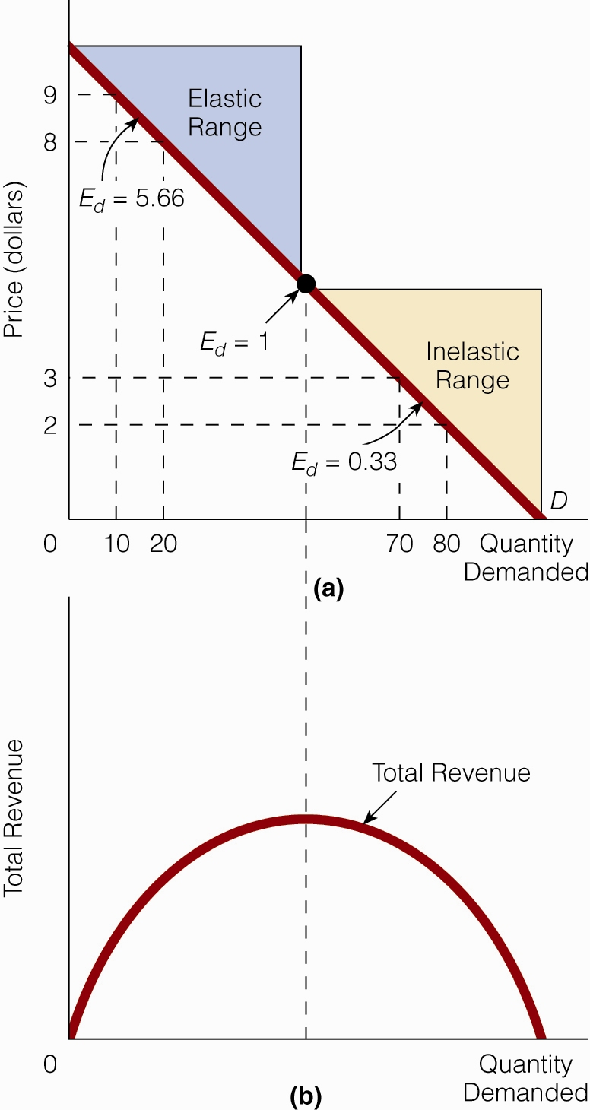

WHEN IN THE PORTION OF THE DEMAND CURVE THAT IS RELATIVELY ELASTIC:

PRICE AND TOTAL REVENUE ARE INVERSELY RELATED

WHEN IN THE PORTION OF THE DEMAND CURVE THAT IS RELATIVELY INELASTIC:

PRICE AND TOTAL REVENUE ARE DIRECTLY RELATED

DETERMINANTS OF PRICE ELASTICITY OF DEMAND

- AVAILABILITY OF SUBSTITUTES (THE LARGER THE NUMBER OF SUBSTITUTES, THE MORE PRICE ELASTIC DEMAND)
- THE PORTION OF INCOME REPRESENTED BY THE PRICE FO THE GOOD. (THE GREATER THE PRICE OF THE GOOD AS A PERCENT OF INCOME, THE MORE PRICE ELASTIC.)
- LUXURY VS. NECESSITY. (LUXURY GOODS ARE MORE ELASTIC THAN NECESSITIES.)
- TIME. (THE LARGER THE TIME PERIOD AVAILABLE FOR SELECTION OF ALTERNATIVES, THE MORE PRICE ELASTIC.)

PRICE ELASTICITY OF SUPPLY

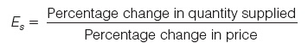

THE KEY DETERMINATE OF THE PRICE ELASTICITY OF SUPPLY IS TIME

WE CAN UNDERSTAND THE EFFECT OF TIME ON PRICE ELASTICITY OF SUPPLY BY DIVIDING TIME INTO THREE PERIODS

- THE VERY SHORT RUN: A TIME PERIOD SO SHORT THAT THE QUANTITY OF NO RESOURCES CAN BE CHANGED. SUPPLY IS PERFECTLY INELASTIC.

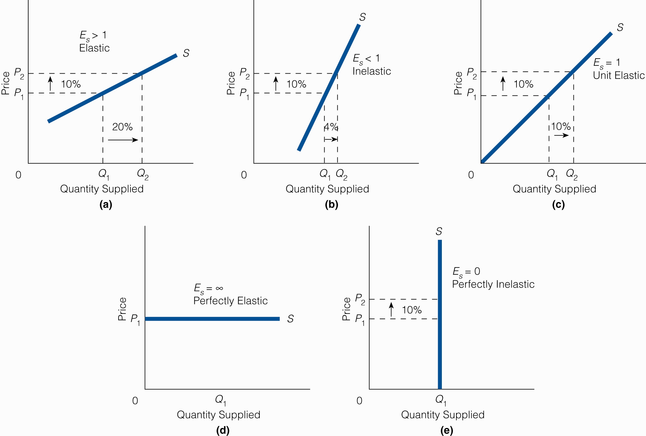

- THE SHORT RUN: A TIME PERIOD LONG ENOUGH TO CHANGE THE QUANTITY OF SOME RESOURCES CAN BE CHANGED (VARIABLE RESOURCES LIKE LABOR). BUT THE QUANTITY OF OTHER RESOURCES CAN NOT BE CHANGED (FIXED RESOURCES LIKE PLANT & EQUIPMENT). SUPPLY IS SOMEWHAT ELASTIC.

- THE LONG RUN: TIME PERIOD IN WHICH THE QUANTITY OF ANY/ALL RESOURCES CAN BE CHANGED (NO FIXED RESOURCES). SUPPLY IS VERY ELASTIC.

