2302 Section 3

Skeleton Notes

CORRECTING THE MISALLOCATIONS OF RESOURCES

THERE ARE TWO SITUATIONS IN WHICH THE MARKET SYSTEM ALONE CAN NOT ALLOCATE RESOURCES TO PRODUCE THE RESULT MOST ADVANTAGEOUS FOR SOCIETY: EXTERNALITIES & PUBLIC GOODS. THE ONLY SOCIAL ENTITY WHICH CAN CORRECT THE SITUATION IS GOVERNMENT. (HERE WE HAVE THE ENTRY OF GOVERNMENT INTO THE MARKET TRANSACTION)

EXTERNALITIES:

EXTERNALITIES ARE EFFECTS, EITHER GOOD OR BAD, RESULTING FROM A MARKET TRANSACTION WHICH IS NOT EXPERIENCED BY EITHER THE BUYER OR SELLER IN THE TRANSACTION. THE EFFECT IS FELT BY THIRD (OUTSIDE) PARTIES TO THE TRANSACTION. (IT IS NOT THE BUYER OF SELLER EXPERIENCING EXTERNALITIES, BUT OTHER INDIVIDUALS.)
EXTERNALITIES FALL INTO TWO CATEGORIES: EXTERNAL COSTS & EXTERNAL BENEFITS.

EXTERNAL COSTS:
COSTS RESULTING FROM A MARKET TRANSACTION WHICH ACCRUE NOT TO THE INDIVIDUALS INVOLVED, BUT TO THIRD PARTIES. THEY ARE COSTS NOT REPRESENTED IN THE MARKET PRICE OF THE PRODUCT. PRESENTS OF EXTERNAL COSTS RESULT IN AN OVER ALLOCATION OF RESOURCES. (TOO MUCH OF THE PRODUCT IS BEING PRODUCED). IF THIS OVER ALLOCATION OF RESOURCES IS CORRECTED (THE EXTERNAL COST IS RECOGNIZED), THEN LESS OF THE PRODUCT WOULD BE PRODUCED AN CONSUMED. (FEWER RESOURCES APPLIED TO THE PRODUCT- MATCHING THE DESIRES OF SOCIETY). EXAMPLE OF EXTERNAL COST: POLLUTION.

GOVERNMENT FORCES THE RECOGNITION OF THE EXTERNAL COST ON THE MARKET TRANSACTION THRU EITHER OF TWO METHODS:

- REGULATIONS WHICH WOULD FORCE THE TRANSACTION PARTICIPANTS TO INCLUDE THE EXT. COST IN THE PRICE OF THE PRODUCT.

- A TAX APPROXIMATING THE EXTERNAL COST ON EACH PRODUCT PRODUCED.

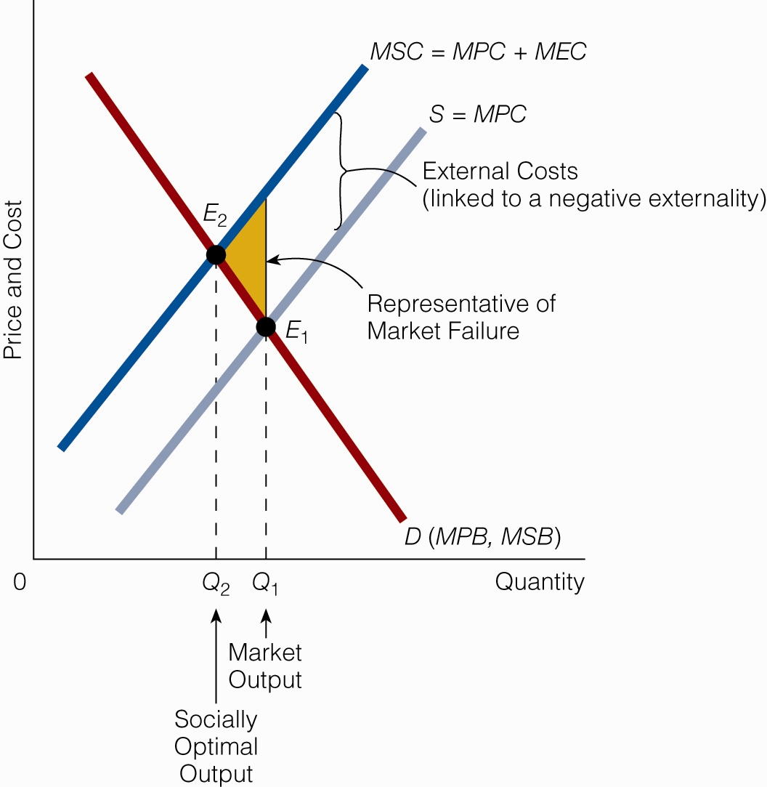

Creating a “ Market Based” approach to reduce pollution - New Thinking on Resolving External Costs

** Creating a market for trading pollution rights would provide an incentive not to pollute and would provide revenue for environmental improvement.

How the market would function

- Responsible agency would determine the specific amount of pollutant that could be discharge into the environment.
- These pollution rights are made available for sale to polluters each year. The supply of pollution rights is fixed – creating a perfectly inelastic supply curve
- The market forces an equilibrium price for pollution. This forces firms to reduce pollution through reduction in production of their products or installing production control equipment
- Over time as population and production increases, the inelastic pollution rights supply curve insures that the cost of pollution increases continuing the incentive for firms to maintain controls on the creation of pollution.
- The market reduces the cost to society (measured by the use of resources) to maintain/reduce the overall level of pollution in the environment by allowing firms with high pollution control costs to purchase pollution credits from firms with low pollution control costs.

EXTERNAL BENEFITS:
EXTERNAL BENEFITS ARE BENEFITS WHICH ACCRUE NOT TO THOSE INVOLVED IN THE TRANSACTION, BUT TO THIRD PARTIES. THESE BENEFITS ARE NOT RECOGNIZED IN THE MARKET PRICE OF THE PRODUCT (BUYER DOES NOT EXPERIENCE THESE BENEFITS SO THEY ARE NOT A FACTOR IN THE BUYER’S DEMAND FOR THE PRODUCT).
PRESENCE OF EXTERNAL BENEFITS RESULT IN AN UNDERALLOCATION OF RESOURCES TO THE PRODUCTION OF THIS PRODUCT (SOCIETY WOULD WANT MORE OF THIS PRODUCT CONSUMED). EXAMPLE OF EXTERNAL BENEFIT: EDUCATION

GOVERNMENT WOULD ADDRESS THE PRESENCE OF EXTERNAL BENEFITS IN ONE OF TWO WAYS:

- SUBSIDIES (PAYMENTS TO THE PRODUCER FOR EACH UNIT FO THE GOOD PRODUCED).
- BECOME A PRODUCER OF THE GOOD ITSELF.

EITHER OF THESE WOULD LOWER THE PRICE OF THE PRODUCT, RESULTING IN AN INCREASE IN EQUILIBRIUM QUANTITY PRODUCED.

PUBLIC GOODS
PUBLIC GOODS EXIST IN THOSE INSTANCES WHEN THE MARKET SYSTEM CAN NOT ALLOCATE ANY RESOURCES TO THE PRODUCTION OF A PARTICULAR PRODUCT. THERE ARE TWO FACTORS WHICH LEAD TO THIS SITUATION:

- CONSUMPTION OF THE GOOD BY ONE INDIVIDUAL DOES NOT LIMIT ITS CONSUMPTION BY OTHERS (NON RIVALROUS IN CONSUMPTION)
- THE BENEFITS OF THE GOOD CAN NOT BE EXCLUDED FROM SELECTED INDIVIDUALS (NON EXCLUDABILITY)

WHEN THESE FACTORS ARE PRESENT, ONLY GOVERNMENT CAN SUPPLY THE GOOD. ONLY ITS AUTHORITARIAN POWER CAN ASSIGN RESOURCES TO THE PRODUCTION OF THIS GOOD.
EXAMPLE OF PUBLIC GOOD- NATIONAL DEFENSE

REMEMBER, NOT ALL GOODS PRODUCED BY GOVERNMENT ARE ACTUAL PUBLIC GOODS. TRUE PUBLIC GOODS MUST MEET BOTH OF THE ABOVE CONDITIONS.

ANTITRUST LEGISLATION & MERGERS

MARKET POWER – SINGLE PRODUCER OR CONSUMER HAS THE ABILITY TO ALTER THE MARKET PRICE OF A SPECIFIC PRODUCT. THIS RESTRICTS THE MARKET’S ABILITY TO ADJUST THE APPLICATION OF RESOURCES TO THE PURPOSES MOST DESIRED BY SOCIETY THRU THE NORMAL PRICE MECHANISM

TRUST – MONOPOLY

AFTER THE CIVIL WAR THE U.S. ECONOMY EXPERIENCED A RAPID CONSOLICATION OF ECONOMIC POWER IN THE EMERGING INDUSTRIAL INDUSTRIES WITHIN THE HANDS OF A FEW INDIVIDUALS SUCH AS J. P. MORGAN, ANDREW CARNEGEI, AND JOHN D ROCKEFELLER. THE ORGANIZATIONS WHICH THESE INDIVIDUALS CONTROLLED GAINED INCREASING SIZE AND FINANCIAL STRENGTH WHICH ALLOWED THEM TO DESTROY THE “COMPETITION” ON WHICH A SOUND FREE MARKET MUST EXIST. IN THE LANGUAGE OF THAT DAY, THESE MONOPOLIES WERE CALLED “TRUSTS”.

A POLITICAL MOVEMENT DEVELOPED IN THE LATE 19TH & EARLY 20TH CENTURY CALLED THE PROGRESSIVE MOVEMENT, WHICH SOUGHT TO OFFSET AND REVERSE THE MARKET POWER OF THE TRUSTS. THE PROGRESSIVE MOVEMENT WAS A LEADING FORCE BEHIND THE ENACTMENT OF THE “ANTITRUST” LAWS STILL IN USE TODAY.

THE SHERMAN ACT (1890)

THE SHERMAN ACT PROHIBITS “CONSPIRACIES IN RESTRAINT OF TRADE” WHICH THREATEN TO MONOPOLIZE TRADE.

IN 1911 THE SHERMAN ACT WAS USED TO BREAK UP THE STANDARD OIL TRUST, AND THE AMERICAN TOBACCO COMPANY

IN ITS EARLY IMPLEMENTATION, ONE LIMITATION OF THE SHERMAN ACT WAS ITS VAGUE WORDING. THE FEDERAL COURTS WERE LEFT TO DEVELOP RULINGS INTERPRETING ITS INTENT. IT WAS LEFT TO THE COURTS TO DECIDE WHAT ACTIONS WERE ILLEGAL.

ONE IMPORTANT SUPREME COURT INTERPRETATION IS REFERED TO AS “THE RULE OF REASON” WHICH HELD THAT TRADE RESTAINTS WERE NOT NECESSARILY ILLEGAL, ONLY IF IT IS “UNREASONABLE”. UNDER THE RULE OF REASON SIZE OF THE FIRM ALONE IS NOT AN OFFENSE TO THE LAW.

THE SHERMAN ACT AS INTERPRETED BY THE COURTS DID NOT COMPLETELY ACHIEVE THE RESULTS HOPED FOR BY THE PROGRESSIVES.
THE CLAYTON ACT ( 1914)

TO CORRECT THE PRECEIVED SHORTCOMINGS IN THE WORDING OF THE SHERMAN ACT, THE CLAYTON ACT AS CREATED.

THE CLAYTON ACT SPECIFICALLY PROHIBITED FIVE BUSINESS PRACTICES WHICH THE COURTS HAD FOUND DID NOT VIOLATE THE SHERMAN ANTITRUST ACT:

- PRICE DISCRIMINATION (UNLESS JUSTIFIED BASED ON COST DIFFERENCES). EXAMPLE OF PRICE DISCRIMINATION IS PREDATORY PRICING – TEMPORARILY LOWERING PRICING BY DOMINANT FIRM TO DRIVE WEAKER RIVALS OUT OF THE MARKET
- INTERLOCKING STOCKHOLDING – PRACTIVCE OF EXCESSIVE BUYING OF ONE FIRM’S STOCK BY ANOTHER FIRM IN THE SAME INDUSTRY.
- INTERLOCKING DIRECTORATES - INDIVIDUAL ON THE BOARD OF DIRECTORS OF MORE THAN ONE FIRM IN THE SAME INDUSTRY
- TYING CONTRACTS – SELLING ONE PRODUCT ONLY ON THE CONDITION THAT ANOTHER PRODUCT MUST ALSO BE PURCHASED.
- EXCLUSIVE DEALING CONTRACTS – RESTRICT RETAILER FROM CARRYING THE PRODUCTS OF A RIVAL FIRM

THE FEDERAL TRADE COMMISSION ACT (1914)

CREATED THE FEDERAL TRADE COMMISSION AS THE FEDERAL AGENCY RESPONSIBLE FOR IDENTIFING ANTICOMPETITIVE PRACTICES, AND ENFORCING ANTITRUST LAWS.

ALONG WITH THE FEDERAL TRADE COMMISSION, THE JUSTICE DEPARTMENT IS ALSO CHARGED WITH INVESTIGATIN AND PROSECUTING ANTITRUST CASES.

HAVING TWO GOVERNMENT AGENCIES INVOLVED IN THE REGULATOR PROCESS CAN LEAD TO INTERAGENCY CONFLICTS:

- Converging industries—especially in the realm of technology—have blurred the agencies' traditional lines of responsibility.
- The two agencies have often held conflicting views about fundamental issues, including when they should challenge alleged monopolistic behavior by companies.
- The two agencies have different legal procedures for challenging business deals or practices they believe to be anticompetitive.
  - The Justice Department must work through the federal court system and face judges who are often skeptical of antitrust law.
  - The FTC, by contrast, tries cases in its own administrative law system. This, many lawyers believe, provides a significant home-court advantage. Rulings by the FTC's administrative system can be appealed in federal court, but it takes so long that many parties prefer to abandon a deal or settle a case first.

BECAUSE ANTITRUST LAWS ARE WRITTEN BY CONGRESS AND ANTITRUST REGULATION IS PERFORMED BY THE EXECUTIVE BRANCH, IT IS IMPOSSIBLE TO REMOVE POLITICS FROM THE PROCESS.

Each Executive administration has its viewpoint as how to deal with antitrust issues:

- What type of Antitrust Enforcement & Regulation Philosophy do regulators decide to follow?
- Active Antitrust Perspective – Competition is insufficient in many cases in achieving fairness to consumers & competing firms. Active, strict enforcement of antitrust laws is required. Regulators must be more ready to take action to prevent mergers and more likely to see actions of firms as being noncompetitive.
- Laissez-fair Perspective – Antitrust intervention is largely unnecessary. Monopolies that do result are from a firm’s superior innovativeness or efficiency. However if a monopolist were to attempt to exploit its monopoly power to raise prices, this creates the profit incentive which draws competing firms to develop alternative technologies and products.

- WHAT IS THE PROPER AREA TO REVIEW TO ACHIEVE DESIRED MARKET OUTCOMES ?
  - INDUSTRY STRUCTURE (MARKET CONCENTRATION)
  - MARKET BEHAVIOR (NON COMPETITIVE ACTION)

Complicating Factors in Antitrust Regulation:
- REGULATORS HAVE LIMITED RESOURCES AT THEIR DISPOSAL
- SOME CONCENTRATION OF MARKET SHARE MAY INCREASE EFFICIENCY IN A GIVEN INDUSTRY
- THE INTERNATIONAL MARKET MAY ALLOW FOR LARGER DOMESTIC FIRMS WITH NO REDUCTION IN COMPETITION
- Capture Theory of Regulation - No matter the original motive for the initial establishment of the regulatory agency, eventually the agency will be “captured” (controlled) by the special interests of the industry being regulated.
- Public Choice Theory of Regulation – Believes regulators will ultimately use their regulatory power to do what is in the regulator’s best interest (enhance the power, and budget of the regulatory agency.)

SHORT REVIEW OF HOW ENFORCEMENT VIEW HAS SHIFTED BETWEEN INDUSTRY STRUCTURE AND MARKET BEHAVIOR
- INITIAL ENFORCEMENT EFFORTS WERE DIRECTED TOWARD INDUSTRY STRUCTURE.
- ONE EARLY COURT INTERPRETATION WAS REFERED TO AS THE “60 PERCENT RULE”. THIS HELD THAT IF A FIRM HAD AT LEAST A 60% SHARE OF A MARKET ITS ACTIONS WOULD BE SUBJECT TO SPECIAL ATTENTION DUE TO ITS SIZE ALONE.
- IN 1982 THE JUSTICE DEPARTMENT ADOPTED THE HERFINDAHL-HIRSHMAN INDEX AS A GUIDELINE FOR INTERVENTION IN PROPOSED MERGERS. (see below)
- 1992 THE JUSTICE DEPT. EXPANDED ITS INVESTIGATION TO INCLUDE BARRIERS TO ENTRY IN THE INDUSTRY. LOW BARRIERS TO ENTRY ACT AS A NATURAL MARKET REGULATOR TO EXCESSES RESULTING FROM HIGH INDUSTRY CONCENTRATION
- 1996 THE JUSTICE DEPT. EXPANDED ITS REVIEW PROCESS TO INCLUDE EMPHASIS ON CONSUMER WELFARE (GREATER EFFICIENCY AND LOWER COST). MERGERS/ACQUISITIONS WHICH WOULD RESULT IN GREATER INDUSTRY EFFICIENCY ARE LESS LIKELY TO BE CHALLENGED

THE HERFINDAHL-HIRSHMAN INDEX - A MEASURE OF MARKET CONCENTRATION. (It is calculated by squaring the market share of each firm and summing the resulting numbers) IT WEIGHS THE MARKET SHARE OF EACH FIRM RATHER THAN JUST THE COMBINED MARKET SHARE OF THE TOP FOUR FIRMS. AN HHI BELOW1,000 IS CONSIDERED UNCONCENTRATED. AN HHI ABOVE 1,800 IS CONSIDERED HIGHLY CONCENTRATED.

MERGERS
THERE ARE THREE TYPES OF MERGERS:

HORIZONTAL MERGERS – TWO OR MORE FIRMS AT THE SAME STAGE IN A GIVEN INDUSTRY

VERTICAL MERGERS – TWO OR MORE FIRMS AT DIFFERENT STAGES IN A GIVEN INDUSTRY

CONGLOMERATE MERGER – FIRMS WHICH ARE IN COMPLETELY UNRELATED INDUSTRIES

DEMAND FOR RESOURCES
IN SIMPLE TERMS THE DEMAND FOR RESOURCES IS A DERIVED DEMAND: (DEMAND FOR ANY RESOURCE IS DEPENDENT UPON THE DEMAND FOR THE PRODUCT THAT THE RESOURCE IS USED TO PRODUCE.)

A MORE ANALYTICAL EXPLANATION FOR RESOURCE DEMAND
IN DECIDING THE QUANTITY OF A PARTICULAR RESOURCE TO EMPLOY IN ITS PRODUCTION PROCESS, THE FIRM COMPARES THE MARGINAL REVENUE PRODUCT OF LABOR (MRP) WITH THE MARGINAL COST (MC) OF LABOR.
MARGINAL REVENUE PRODUCT OF LABOR- THE ADDITIONAL REVENUE GENERATED FROM SELLING THE OUTPUT PRODUCED BY ONE MORE UNIT OF A LABOR.
MRP = marginal product x price of output
THE FIRM COMPARES THE MRP AND THE MC FOR THE NEXT UNIT OF LABOR. IF THE MRP IS GREATER THAN THE MC FOR THE NEXT UNIT OF LABOR, THEN THE FIRM’S PROFITS WOULD BE INCREASED AND THE UNIT OF LABOR SHOULD BE EMPLOYED. IF THE MRP IS LESS THAN THE MC, THEN THE FIRM’S PROFITS WOULD DECLINE AND THE UNIT OF LABOR SHOULD NOT BE EMPLOYED.
THERE ARE SEVERAL FACTORS WHICH INFLUENCE THE DEMAND FOR A PARTICULAR RESOURCE:
  - PRICE OF THE FINAL GOOD PRODUCED
  - PRICE OF THE RESOURCE
  - THE PRODUCTIVITY OF THE RESOURCE (TRAINING & TECHNOLOGY) .(PRODUCTIVITY DETERMINES THE QUANTITY OF THE FINAL GOOD EACH ADDITIONAL UNIT OF THE RESOURCE WILL GENERATE IN THE PRODUCTION PROCESS)
  - PRICE OF THE OTHER RESOURCES (SUBSTITUTES & COMPLIMENTS)

Selection of Resource Quantity
 | Units of Labor |  | Total Output |  | Marginal Product |  | Product Price |  | Total Revenue |  | Marginal Revenue Product (MRP) |  | Cost of Resource Unit
 | 1 |  | 14 |  | 14 |  | $5 |  | $70 |  | $70
 | 2 |  | 26 |  | 12 |  | $5 |  | $130 |  | $60
 | 3 |  | 37 |  | 11 |  | $5 |  | $185 |  | $55
 | 4 |  | 46 |  | 9 |  | $5 |  | $230 |  | $45
 | 5 |  | 53 |  | 7 |  | $5 |  | $265 |  | $35
 | 6 |  | 58 |  | 5 |  | $5 |  | $290 |  | $25
 | 7 |  | 62 |  | 4 |  | $5 |  | $310 |  | $20

WHY EARNINGS DIFFERENCES BETWEEN INDIVIDUALS AND BETWEEN OCCUPATIONS

A) DIFFERENCES IN WORKERS
- PRODUCTIVITY/SPECIALIZED SKILLS
- WORKER PREFERENCES (TRADE OFF BETWEEN MONEY EARNINGS & INTANGIBLES
- RACE & GENDER DISCRIMINATION

B) DIFFERENCES IN JOBS
- LOCATION OF JOBS
- WORKING CONDITIONS
- OPPORTUNITY FOR TRAINING & SKILL ENHANCING

C) IMMOBILITY OF RESOURCES (LABOR)
- TEMPORARY DISEQUILIBRIUM FROM CHANGES IN THE ECONOMY
- INSTITUTIONAL RESTRICTIONS (REGULATION & LICENSING)

TOTAL COMPENSATIONS IS NOT ONLY MONETARY EARNINGS. FRINGE BENEFITS ARE ALSO PART OF TOTAL COMPENSATION
- HIGHER FRINGE BENEFITS OFFSET HIGHER MONETARY COMPENSATION
- MANDATED FRINGE BENEFITS MAYBE AN INEFFICIENT FORM OF COMPENSATION FOR ALL EMPLOYEES

Important to Note:
- THE ONLY WAY THE REAL WAGE LEVEL (THE QUANTITY OF GOODS AND SERVICES MONETARY WAGE WILL BUY) CAN BE INCREASED IS THRU HIGHER PRODUCTIVITY (GREATER OUTPUT PER WORKER HOUR).
- IMPROVEMENT IN TECHNOLOGY AND HUMAN CAPITAL (TRAINING) LEAD TO HIGHER PRODUCTIVITY.

FACTORS WHICH RESTRICT PRODUCTIVITY GAIN
- SLOW CAPITAL FORMATION
- HIGHER ENERGY PRICES
- INCREASE IN YOUTHFUL, INEXPERIENCED INDIVIDUALS AS PERCENTAGE OF THE TOTAL WORK FORCE.
- LOWER LEVEL OF EDUCATION OF NEW ENTRANTS IN THE WORK FORCE
- GROWTH OF GOVERNMENT EXPENDITURES
- INCREASED GOVERNMENT REGULATION
Note: The reverse of 1 thru 6 will increase productivity gains.

FINANCIAL MARKETS: RISK & UNCERTAINTY

INVESTMENT: PURCHASE, CONSTRUCTION, OR DEVELOPMENT OF NEW
CAPITAL RESOURCES

SAVINGS: AFTER TAX INCOME NOT SPENT ON CURRENT CONSUMPTION

- “Saving” is the act of holding funds rather than spending them, while “Savings” are the funds held

SAVINGS (MONEY SUPPLY CURVE) PROVIDES THE PRIMARY SOURCE OF FUNDS FOR INVESTMENT (MONEY DEMAND CURVE)

IN THE MONEY MARKET, THE DEMAND FOR FUNDS IS EQUATED TO THE SUPPLY OF FUNDS BY THE INTEREST RATE.

- THE INTEREST RATE IS THE COST OF MONEY

THE NOMINAL INTEREST RATE (THE RATE PAID BY THE USER OF THE FUNDS) IS DETERMINED BY FOUR FACTORS:
- THE REAL RATE OF INTEREST: also referred to as THE RISK FREE RETURN RATE (The rate of interest charged when there is absolutely no risk of default.)
- THE INFLATION RATE (How fast money loses value over time)
- THE FINANCIAL RISK also called THE RISK PREMIUM (What chance is there that the borrower would default on the transaction.)
- TIME (The length of time required for the transaction to be completed.)
  - THE LENGTH OF TIME REQUIRED FOR THE TRANSACTION TO BE COMPLETED. INCREASES THE UNCERTAINTY OF BOTH THE INFLATION RATE AND THE RISK PREMIUM)

- The real interest rate has historically been relatively constant at between 1% and 2 %
- The variation in the nominal interest rate between transactions and the fluctuation in the nominal interest rate over time is due to changes in the inflation rate or financial risk.
- Length of Time will likely affect expectations regarding inflation and risk.

THE TIME VALUE OF MONEY

THE LONGER THE PERIOD OF TIME INVOLVED, THE HIGHER THE INTEREST RATE/RATE OF RETURN REQUIRED (THIS IS REFERRED TO AS THE TIME VALUE OF MONEY)

THE TIME VALUE OF MONEY CAN BE COMPUTED USING PRESENT DISCOUNTED VALUE FACTORS WHICH CONVERT THE VALUE OF FUNDS RECEIVED IN THE FUTURE INTO THE VALUE OF TODAY’S DOLLARS.

PRESENT VALUE: THE VALUE IN TODAY’S DOLLARS FOR RECEIPT OF
FUNDS IN THE FUTURE

DISCOUNT: TO ADJUST VALUE OF FUNDS RECEIVED IN THE FUTURE TO TODAY’S PRESENT VALUE.

THE PRESENT VALUE OF A FUTURE DOLLAR IS INVERSELY RELATED TO
- INTEREST RATE
- LENGTH OF TIME UNTIL THE FUTURE PAYMENT IS RECEIVED.

THE FUNCTION OF THE ENTREPRENEUR IS TO SELECT FROM VARIOUS INVESTMENT OPTIONS THOSE THAT WILL GENERATE THE GREATER FUTURE INCOME COMPARED TO THE COST OF FUNDS USES.

THE CAPITALIST ECONOMIC SYSTEM RESULTS IN THE GREATEST CREATION OF CAPITAL RESOURCES DUE TO SEVERAL FACTORS
- FREE FINANCIAL MARKETS ALLOW THE EFFICIENT DIRECTION OF INVESTMENT FUNDS
- SECURE PROPERTY RIGHTS ENSUE WEALTH CREATING INVESTMENTS WILL BE PROFITABLE OVER TIME.

FREE CAPITAL MARKETS ALLOW THE EFFICIENT DIRECTION OF INVESTMENT FUND.

SECURE PROPERTY RIGHTS ENSURE WEALTH CREATING INVESTMENTS WILL BE PROFITABLE OVER TIME.

COUNTRIES WITH HIGHER LEVER OF INVESTMENT TODAY WILL HAVE HIGHER INCOME LEVERS IN THE FUTURE.

TAXES

INCOME: FLOW OF ANNUAL FUNDS EARNED BY OWNERS OF ECONOMIC RESOURCES.

WEALTH: MARKET VALUE OF ASSETS

PROGRESSIVE TAX: TAX RATES RISE AS INCOME LEVEL RISES

REGRESSIVE TAX: TAX RATES FALL AS INCOME LEVEL RISES

NOMINAL TAX RATE: TAX PAID/ TAXABLE INCOME

MARGINAL TAX RATE: PERCENTAGE OF NEXT DOLLAR OF INCOME PAID IN TAX

EFFECTIVE TAX RATE: TAX PAID/ TOTAL INCOME

MEASURE OF TAX FAIRNESS: COMPARE NOMINAL TAX RATE WITH THE EFFECTIVE TAX RATE

IN DETERMINING THE ECONOMIC IMPACT OF A TAX, THE MARGINAL RATE IS MORE IMPORTANT THAN THE NOMINAL RATE

MOST SALES TAXES ARE REGRESSIVE

LOTTERIES ARE REGRESSIVE

International Trade

Comparative Advantage & the Open Economy

International Trade: Trade between people and businesses who operate in different countries.
International Trade exists because countries can make themselves better off through trade.

The Correlation Between World Trade & World Real GDP
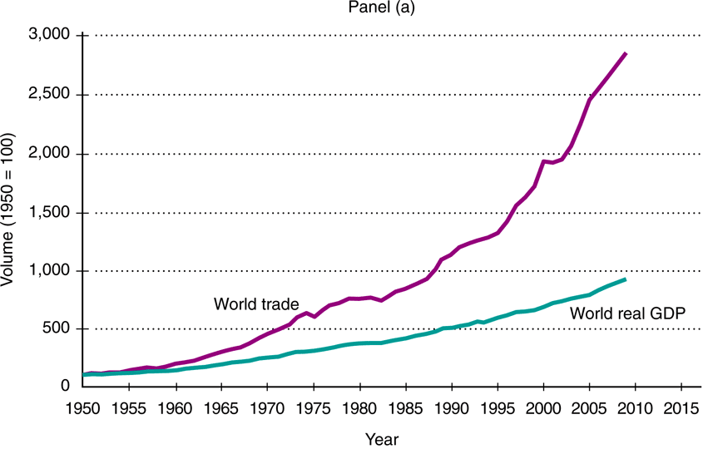

Exports – goods produced here and sold to people/firms in other countries

Imports – goods produced in foreign countries and sold to people/firms here
- Terms of trade: The rate at which units of one product can be exchanged for units of another product. (How much of one thing is given up for how much of something else.)

Growth in U.S. Imports, Exports & Trade Deficit

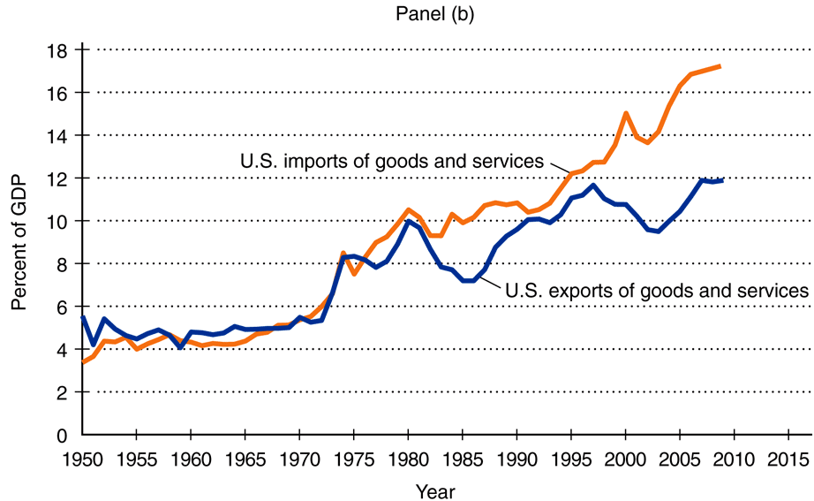

International Trade

Trade deficit – imports exceed exports.

Outcome:

we end up with more satisfying goods than they do

they end up with unspent dollars

What do they do with those dollars?

they save them in banks

banks then loan them to borrowers who want to buy assets priced in dollars

International trade brings foreign-made goods to the US and generates foreign investment in US assets

Important to remember:
Although now a smaller percentage of total world trade, than in the half century following WWII, the U.S. still accounts for the largest volume of international trade (both imports & exports) as measured in dollars.

Why Individuals/Countries engage in International Trade

Specialization and Trade

Country A has the comparative advantage over Country B if:

Country A can produce a good at a lower opportunity cost than country B can.

Country A should specialize in that good and country B should become country A’s customer.
- Country A should buy things it wants from other countries which have the comparative advantage on those items.
- Terms of Trade for country A are how much of the product it makes are required to obtain the products it wants from other countries.

Countries learn they have a comparative advantage by the basic economic activity of individual producers in the country trying to earn profits and buying low and selling high in the process.
- When trading countries follow the idea of comparative advantage in their production/trading practices they all benefit from an increase in total production and higher living standard.
Example of How Comparative Advantage
Production Possibility Curves for
U.S. Japan
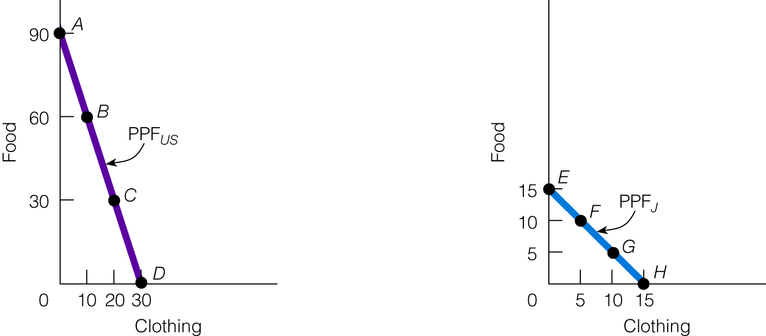

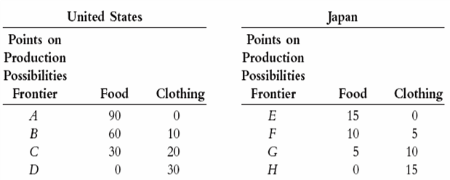

Specialization and Trade
- U.S. has a comparative advantage in producing food.
- Japan has a comparative advantage in producing clothing.
- Terms of trade for U.S. is how much food it must sell to obtain clothing.
- Terms of trade for Japan is how much clothing it must sell to obtain food.

Result of Pursuing Comparative Advantage

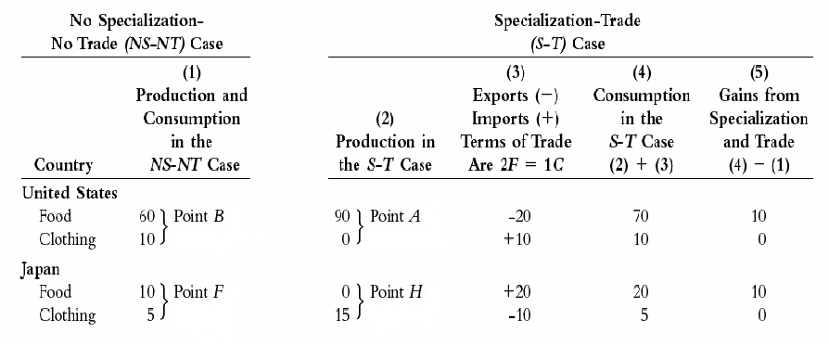

Following the Principle of Comparative Advantage:
- U.S. produces 90 units of food and no clothing.
- Japan produces 15 units of clothing and no food.
- U.S. has gained 10 additional units of food
- Japan has gained 10 additional units of food

Benefits of Specialization and Trade

People in countries that specialize and trade have:

expertise in production

efficiency in resource use

a wider choice of goods

goods at lower prices

a higher standard of living

What is the Outcome of Free International Trade?
Free international trade and investment will increase the living standard of all trading countries.

In each country, high cost, internationally noncompetitive firms lose sales.

cut back on production or go out of business

lay off workers; destroy jobs

In each country, low cost, internationally competitive firms gain sales.

expand production

hire more workers; create jobs

Increased international trade requires expansion of the transportation industry.

create jobs in transportation

In each country, consumers are better off:

they pay less for goods

they have a wider variety to choose from

their income can buy more goods

their standard of living goes up

In each country, resources are more efficiently used by specialists

more is produced from the same consumption of resources

Arguments Against Free Trade

National defense argument:
To protect its military assets countries must maintain a supply of industrial producers. Countries must also regulate/restrict transfer of military sensitive technologies.

Infant industry argument:

New industries need to be protected from foreign competition so they can grow and become strong enough to compete.

Antidumping argument:
Protect domestic producers’ market share from unfair dumping by foreign competitors. (Dumping – selling a good or service abroad below the price charged in the home market, or below the cost of production).

Foreign subsidy argument:
Protect domestic producers’ market share from foreign producers who are receiving unfair financial support from their home governments
(Subsidy – payments by govern based upon production)

Low wages argument:
Protect domestic producers’ market share from foreign producers who benefit from unfair low wages in their home country. This also protects the wage rate of the domestic workers.

Saving domestic jobs argument:
National economic health requires that we maintain current jobs in domestic industries being pressed by foreign competition, and to maintain current wage levels in those industries

The bottom line reason that Domestic high cost, noncompetitive industries seek protection from government from foreign competition.

They are afraid of:

Loss of jobs

Loss of sales

Going out of business

Protectionist Government Policies

Government imposes tariffs or quotas in imported goods.

Tariff – a tax on each imported good

quota – a restriction on the number of goods that can be imported

Results of Protection Policy

In both countries:

High cost, inefficient firms win.

Low cost, inefficient firms lose.

Consumers lose due to higher prices, less alternatives.

Export firms lose sales.

There is a net job loss.

In both countries, standard of living falls.
Important to remember
tariffs and quotas benefit the producers in protected industries and their employees at the expense of consumers.

Movement Toward Free World Trade

The Great Depreciation was worsened to worldwide tariffs enacted in the mistaken belief that a tariff would protect a counties domestic production and employment. The U.S. participated in this with the Smoot-Hawley Tariff Act of 1930.

After WWII, the U.S. tool the lead in moving the world economy toward more open economic trade.

History of U.S. Tariff Charges
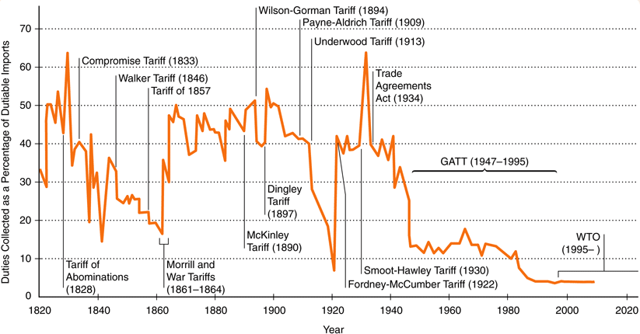

1947 – GATT – General Agreement on Tariffs and Trade (23 countries)

- Equal Non-discriminatory trade treatment for all members
- Reduction of tariffs by multilateral negotiation
- Elimination of import quotas

1995 – WTO – World Trade Organization (145 countries)
- Oversees GATT and other international trade agreements
- Resolves trade disputes
- Holds forum for further rounds of trade negotiations

As a result of international efforts through GATT & WTO to reduce trade barriers and encourage free trade, world trade has increase significantly

INTERNATIONAL FINANCE

CHAPTER 34 – Exchange Rates and Balance of Payments

Foreign Exchange
National currencies are the means by which foreign individuals, firms or countries make foreign purchases or investments.

International commerce requires two transactions:

The exchange of goods for money, and…

The exchange of one currency for another.
- The demand and supply of a nation’s currency is matched in the currency markets.
- The exchange rate is the price of one currency measured in another country’s currency
- The ‘Value of the Dollar” (any currency) is its price in another currency.
- Commonly used terms in currency valuation
- Depreciation – If the dollar depreciates compared to an alternative currency, that means it now takes more dollars to buy the same unit of the alternative currency.
- Appreciation – If the dollar appreciates compared to an alternative currency that means it now takes fewer dollars to buy the same unit of the alternative currency.
- The international value of a country’s currency determines how relatively expensive foreign goods are for its citizens, and how expensive its goods are for foreign consumers.

The Current International Monetary System
- Today’s international monetary system is described as a managed flexible exchange rate system, or managed float.
- For the most part, the exchange rate system is flexible, although nations do periodically intervene in the foreign exchange market to adjust exchange rates.
- Because it is a managed float system, it is difficult to tell if nations at any time are emphasizing the “float” part or the “managed” part.
Proponents of the managed flexible exchange rate system believe it offers several advantages:
- It allows nations to pursue independent monetary policies.
- It solves trade problems without trade restrictions.
- It is flexible and therefore can easily adjust to shocks.
Opponents of the managed flexible exchange rate system believe it has several disadvantages:
- It promotes exchange rate volatility and uncertainty and results in less international trade than would be the case under fixed exchange rates.
- It promotes inflation.
- It corrects trade deficits only a long time after a depreciation in currency; in the interim, it can make things worse.

How the Flexible Foreign Exchange System Operates

Exchange rates change daily as the demand for a currency or the supply of a currency changes.

Exchange rates must always be reciprocals of each other.

Example of U.S. (dollar) and Mexican (peso) exchange market

Mexican sellers of imports to U.S. and U.S. travelers to Mexico have a:

supply of dollars.

demand for pesos.

U.S. sellers of exports to Mexico and Mexican travelers to U.S. have a:

supply of pesos.

demand for dollars.

Graph of Money Markets

Pesos (priced in dollars) Dollars (priced in pesos)

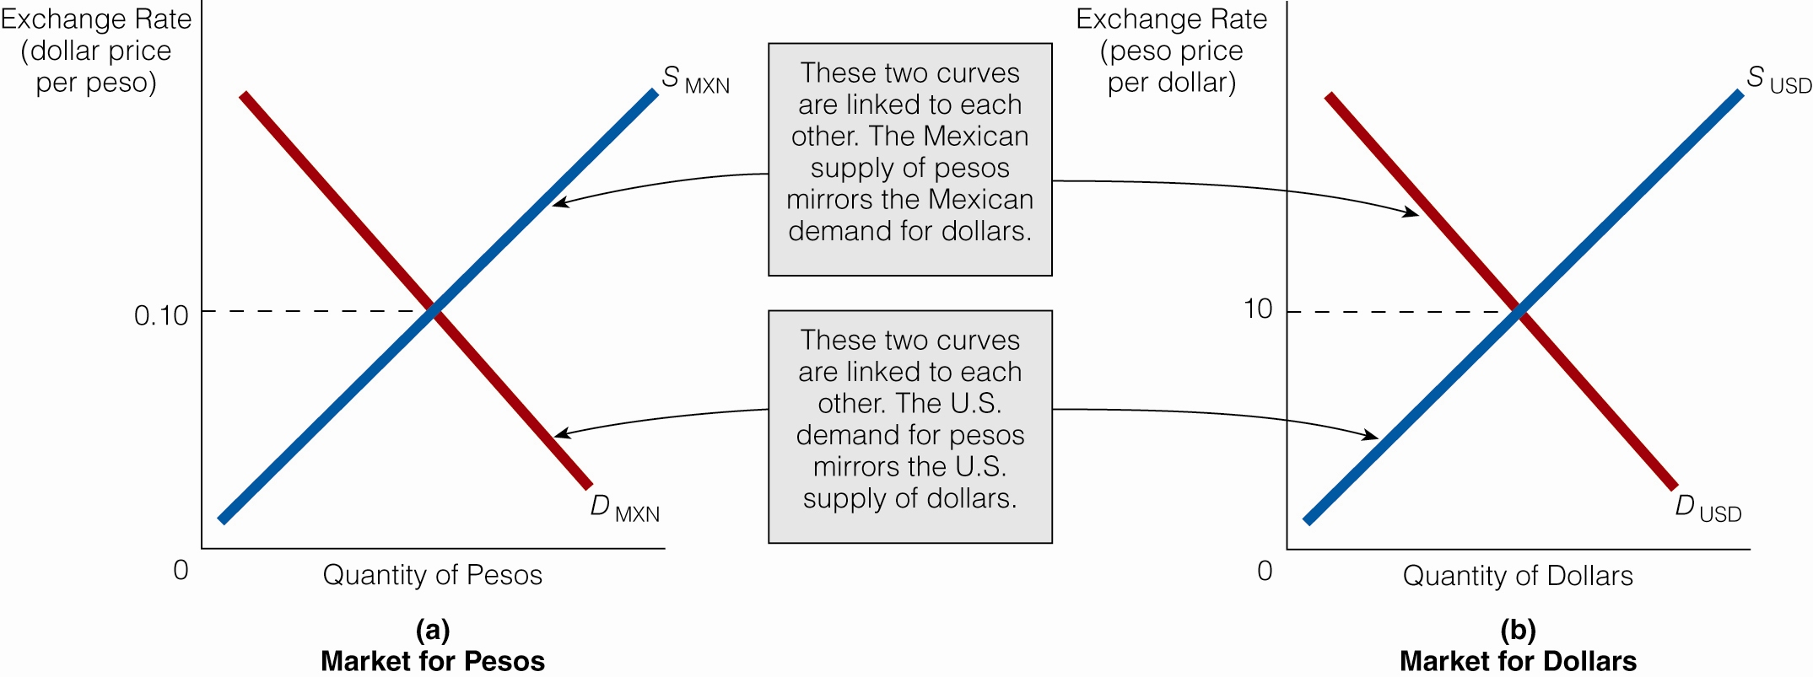

An increase in demand for the peso increases its price in dollars

The peso appreciates and the dollar depreciates

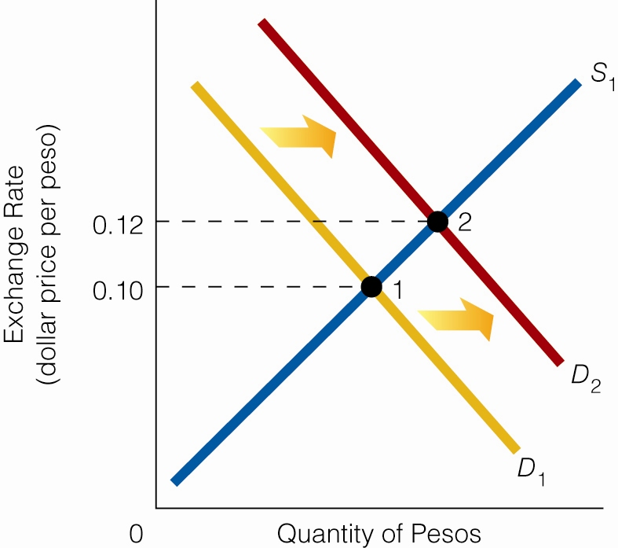

Start: 1 peso = $0.10 or $1.00 = 10 pesos

Next: dollar price of peso rises.

If 1 peso = $0.12

then, $1.00 = 8.33 peso (the peso price of a dollar falls.)

Effects of changes in the exchange rate on Current Account transactions
- If value of the dollar decreases relative to the peso, Mexican products become more expensive, while U.S. goods are less expensive
- If the value of the dollar increase relative to the peso, Mexican products become less expensive, while U.S. goods more expensive.

Fixed Exchange Rates

Each country’s central bank controls its exchange rate at a fixed level.

Shortage of dollars?

Fed buys pesos or gold for dollars, or

Dollar is revalued to a new fixed rate.

Surplus of dollars?

Fed sells pesos or gold for dollars, or

Dollar is devalued to a new fixed rate.

Fixed Exchange Rates

Devaluations are hard on people living in the country

Their money is suddenly less valuable.

Their savings are less valuable.

Everything imported suddenly is higher priced. Domestic prices rise, too.

Inflation is worse.

The central bank has a finite supply of pesos or gold to maintain the fixed rate.

Short History of International Exchange systems:

Gold standard
- A gold standard automatically fixes exchange rates.
- To have an international gold standard, nations must do the following:
- define their currencies in terms of gold;
- stand ready and willing to convert gold into paper money and paper money into gold at a specified rate; and
- link their money supplies to their holdings of gold.
- The change in the money supply that the gold standard sometimes requires has prompted some economists to voice the same argument against the gold standard that is often heard against the fixed exchange rate system: It subjects domestic monetary policy to international instead of domestic considerations

Breton Woods Agreement
- 1944 meeting between Allies.
- Established new international monetary policy to replace the gold standard (disfavored after the Great Depression of the 1930s.
- Created the International Monetary Fund (purpose is to offer advise and lend funds to countries with foreign exchange issues)
- U.S. agreed to maintain its gold prices equivalent to $35 per ounce of gold. And maintain convertibility of the dollar into gold in international clearing transactions between it and foreign countries (referred to as the “gold window”)
1971 President Nixon “closes the gold window” announcing that the U.S. would no longer convert the dollar into gold, and devalued the dollar relative to other international currencies.

1973 President Nixon takes the U.S. dollar of a fixed exchange rate, allowing the dollar to “float” in international exchange.

Other currency arrangements

One region decides to use the same currency:

The Euro area

A country adopts another country’s currency:

Panama and Ecuador use the US $

Albania uses the Euro.

A country pegs its currency to a major currency:

French-speaking Africa pegs to the Euro.
- China is accused of pegging its currency to the dollar

Current Foreign Exchange Rate Arrangements
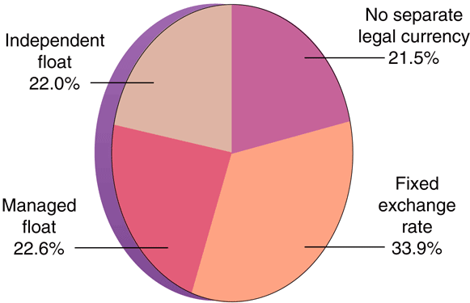

Globalization

Since 1990 end of the Cold War, international trade has expanded significantly.

Markets for goods and services have become worldwide.

Markets for labor also have become worldwide.

Outsourcing

Immigration, legal and illegal.

Outsourcing and the US

Foreign businesses have outsourced more jobs to the US than US business have outsourced abroad!

