Jordan Weissmann, “McDonald's Can't Figure Out How Its Workers Survive on Minimum Wage,” The Atlantic, July 16, 2013
In a financial planning guide for its workers, the company accidentally illustrates precisely how impossible it is to scrape by on a fast food paycheck.
Well this is both embarrassing and deeply telling.
In what appears to have been a gesture of goodwill gone haywire, McDonald's recently teamed up with Visa to create a financial planning site for its low-pay workforce. Unfortunately, whoever wrote the thing seems to have been literally incapable of imagining of how a fast food employee could survive on a minimum wage income. As ThinkProgress and other outlets have reported, the site includes a sample budget that, among other laughable assumptions, presumes that workers will have a second job.
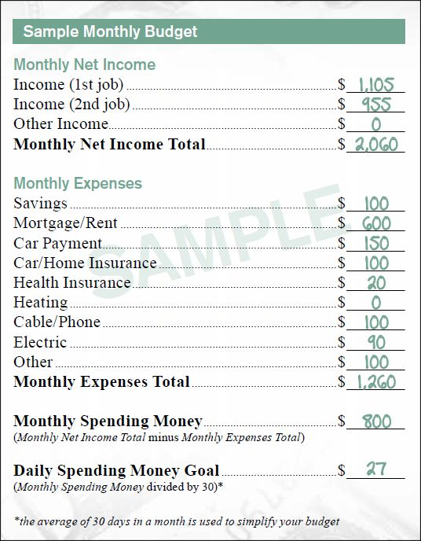

As Jim Cook at Irregular Times notes, the $1,105 figure up top is roughly what the average McDonald's cashier earning $7.72 an hour would take home each month after payroll taxes, if they worked 40 hours a week. So this budget applies to someone just about working two full-time jobs at normal fast-food pay. (The federal minimum wage is just $7.25 an hour, by the way, but 19 states and DC set theirs higher).
A few of the other ridiculous conceits here: This hypothetical worker doesn't pay a heating bill. I guess some utilities are included in their $600 a month rent? (At the end of 2012, average rent in the U.S. was $1,048). Gas and groceries are bundled into $27 a day spending money. And this individual apparently has access to $20 a month healthcare. McDonald's, for its part, charges employees $12.58 a week for the company's most basic health plan. Well, that's if they've been with the company for a year. Otherwise, it's $14.
Now, it's possible that McDonald's and Visa meant this sample budget to reflect a two-person household. That would be a tad more realistic, after all. Unfortunately, the brochure doesn't give any indication that's the case. Nor does it change the fact that most of these expenses would apply to a single person.
Of course, minimum wage workers aren't really entirely on their own, especially if they have children. There are programs like food stamps, Medicaid, and the earned income tax credit to help them along. But that's sort of the point. When large companies make profits by paying their workers unlivable wages, we end up subsidizing their bottom lines.

